 **Foundation 2019-20**

*Foundation Diploma in Art and Design*

**Unit 4 Project Proposal** UAL Awarding Body / CSM Foundation

Candidate Name: **Can Aydin (Jan)** Candidate ID Number: **19022319**

# Curriculum Area: GCD

# Pathway: FC

# UALAB Unit: Unit 4 - Consolidating Practice.

# Project Title:Habits and Obsessions

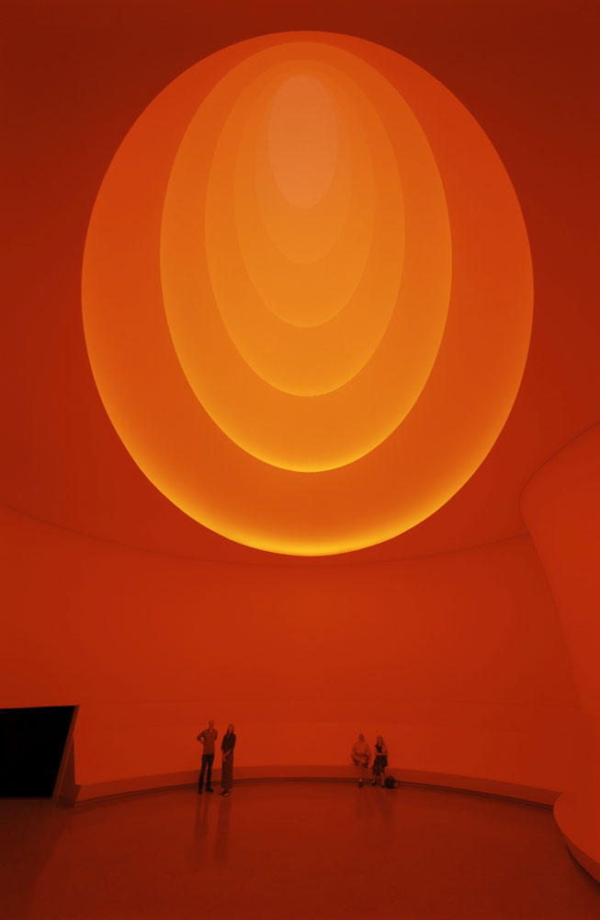

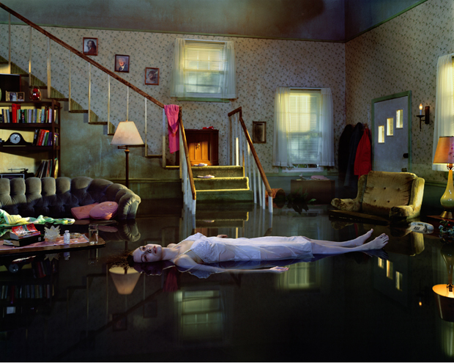 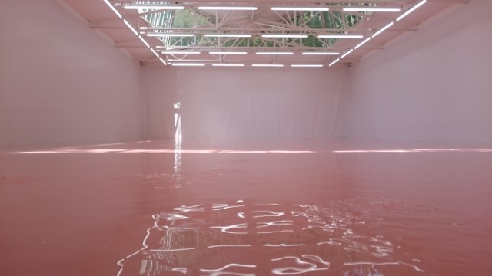

*Gregory Crewdson Pamela Rosenkranz James Turell*

Insert any number of images here to illustrate your project proposal

Project Review (approx. 150 words)

When I took a look at my part two working process, the ones that grabbed my attention were “Self, Portraits and Body Politics”, “Film and the Moving Body”, and last but not least “On Set”. The reason behind this is that they all define my working style in art and design which is mostly set in. The theme comes from the idea of “Purity”, “Innocence”, and “Perfection” where I mostly base my work on soft pastel tones. In my opinion, these three projects were a brief window to all my other ideas both visually and conceptually. There is loads of other aspects that I wanted to research about this topic yet I was confined in the limited time given. Potentially, I might combine all these topics together and form a brand new one which I’m hoping to have a broader and deeper concept. I don’t want to research in classical methods only, but also want to interview different people visit facilities and much more.

Project Concept & Description (approx. 250 words)

For this specific commune project, I eventually became fond of OCD (Obsessive Compulsive Disorder) which is a severe mental issue where a person might be too obsessed with something which makes them quite uncomfortable in daily life. In don’t believe that only a number of people suffer from this disease but everyone does in different context and amount. Some might be obsessed with keeping their houses clean every second and another person might be excessively double checking everything because of their constant anxiety. In conclusion, I want to prove that anyone can suffer by this mental health problem that some won’t even notice it. Throughout the weekly tasks, I want to explore different symptoms of this condition and even explore some basic habits which are not even considered fully as OCD. After the commune project is over, I want to create an immersive series of visuals with characters and a narrative to grab more people’s attention on this situation and make them question if they have symptoms of this as well, and if so how? Besides exploring what might be the reason or a trigger that causes people to develop this illness, I want to break the idea of stereotyping and grouping people based on diseases that is basically natures cause. Coronavirus and the discrimination that came with it was a solid inspiration for me. I want to take inspiration from artists such as Pamela Rosenkranz and James Turell who are fond of using light and other media to convey a certain colour in a way that affects the way we think. I’m sure that the Medicine Man exhibition in the Welcome Collection will play an important part. I also would like to look at the historical aspect where people saw this as a demonic possession and had special treatments for it particularly, cognitive-behaviour therapy.

Project Evaluation (approx. 100 words)

I will most probably note down my observations each day at the end of the project and try to be as discrete as possible from my group mates since I do not want to make them aware of their actions which might end up of them not doing it and my research will fail. I want to record down how the time of the day, our location and our actions affect each person’s obsession and anxiety. I am hoping that at the end of the commune project I will have had personal experiences with OCD and how it affected me and friends during this course of time? Or will it not even affect us?

Proposed Research Resources and Bibliography

nhs.uk. (2020). *OCD*. [online]

What are the signs and symptoms of Obsessive compulsive disorder (OCD). (2020). *What is Obsessive Compulsive Disorder (OCD)*

design boom | architecture & design magazine. (2020). *Pamela Rosenkranz fills swiss pavilion with immaterial elements at Venice biennale 2015*.

Ocdonline.com. (2020). Speak of the Devil [online]

Bristol 24/7. (2020). *Spike Island Open Studios: Meet the Artists: Annabelle Craven-Jones*. [online]

Gagosian. (2020). *Gregory Crewdson | Gagosian*. [online]

JAMESTURELL.com (2020). *James Turell - Google Search*. [online]

Wellcomecollection.org. (2020). Medicine Man [online]

Wilkes, A. and Bowen, H. (2015) 'Art: A Visual History'. London: Dorling Kindersley Limited

Steele, V. (2018) 'Pink: The History of a Punk, Pretty, Powerful Colour'. New York: Thames and Hudson

Project Action Plan and Timetable:

I want to spend a week to explore this theme based on peoples actions around me and try to think of ways to visualise them with light and colour.