Overall, I enjoyed part 1 of the foundation course as I enjoyed most of the projects we did.
my least favourite project was “say it loud” as I don’t like to work with flat materials and I don’t feel passionate about words, doing this project confirmed to me that I am more of a maker and I don’t like using materials that can limit your abilities. Things I learned from this project was that research doesn’t always have to be artist research but can be research from peers and strangers as I liked the way we used others experiences through texting to create outcomes.
I also learned the importance of where you place your work and how it can add to your works meaning.

These works by Viktor and Rolf have words on them but they aren’t on typical places we see words like posters or books which Is unique. If I was to ever add words on garments it would be abstract like this.
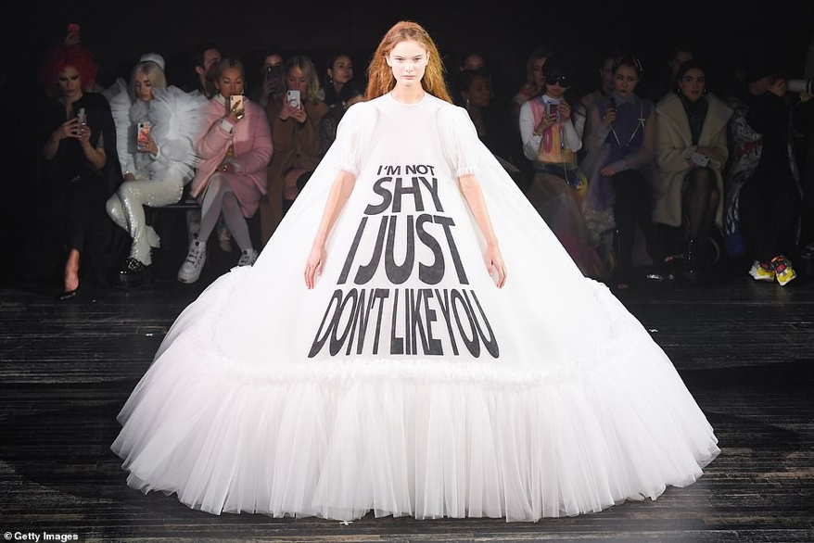

In the “your possessions” project I liked how we projected patterns on a real human. Instead of drawing our design ideas we could project the drawing on a model, photograph it and present it in our books like that.

I was excited to Try JFFA as I’m interested in making for the body. I made a human figure that could be worn as a belt or as a necklace, I liked my idea but I didn’t like the outcome as I used bubble wrap which meant I couldn’t make the shape realistic.

For the “your surroundings” project I liked the idea of taking physical inspiration from physical things and creating them in garment form, I think it’s a good idea however I found it hard as we were using paper to create the shapes. I think my outcome was unique in terms of the ways I placed the shapes together and how they looked like an abstract skirt.

This work by Lucy Mcrae is made using paper which I don’t like using but she’s placed it on the body and used the persons body as a frame which is interesting. I also like the white dress by Viktor and Rolf as it is literally art made into a garment which Is really nice and is definitely something I would love to do in the future.
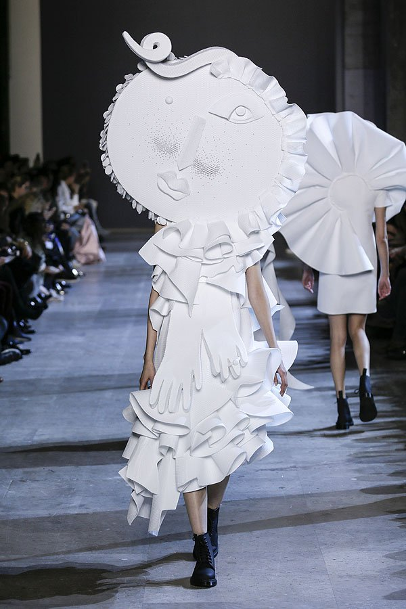
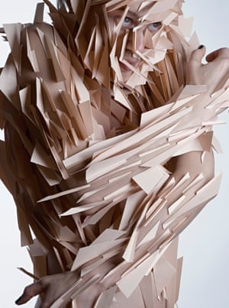
The “Do undo redo“ project taught me that playing around with fabrics allows you to freely experiment and discover fabrics that you thought wouldn’t go well together.

From “your interpretation” I learned that even in textiles the way you place and present your instillations/garments is important and can influence the way your work is seen and the meaning behind it.
Chiharu Shiotas work is an example of this. Firstly, the red yarn isn’t a garment but could be seen as a garment because of the feet and the way that the yarn tightens as it goes to the center makes it more powerful. If the feet weren’t there it wouldn’t have the same effect. I will definitely consider where and what I put with my work in the future.
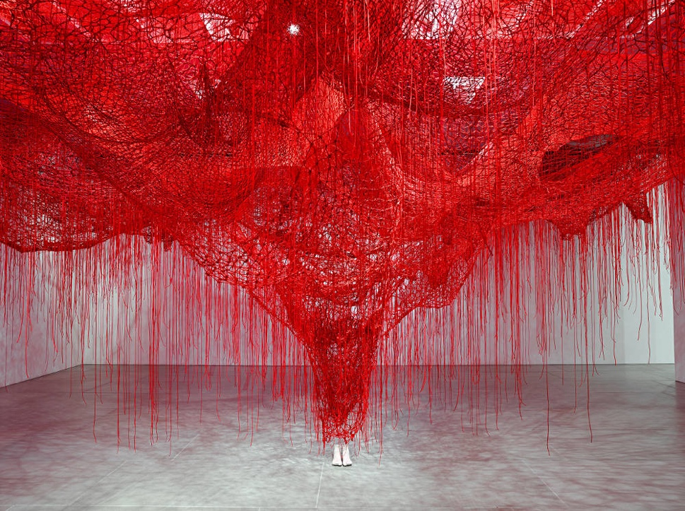

Extension week:

I chose “your data”extention project as I knew I wanted to do something to do with garments and I wanted it to be texture and shape based.

I enjoyed this project as I was free to do what I wanted, this freedom made me forget that I had to show the journey leading to my final piece as I just wanted to start making.

I think that doing this project confirmed my choice as I enjoyed making and experimenting and I enjoyed the challenges I faced.
I think this pathway is suited to me as I love experimenting and trying new things and I believe there are no limits to what you can make.

My dresses circle shape is inspired by my bag and the sharp geometric shape is inspired by the shape of my phone, the long sausages at the bottom of the dress are inspired by the patterns on my bag.
I wanted to keep it looking minimalistic but add detailed techniques to it as contrast.
The biggest struggle was how I was going to present my dress as I planned that it could be a wall hanging and a dress however the way I had made the dress made it hard to actually be worn so I fixed it and it can now be hanged and worn.

To improve I would definitely fix my sewing on the back and I would add machine embroidery around the flower to add layering and texture.
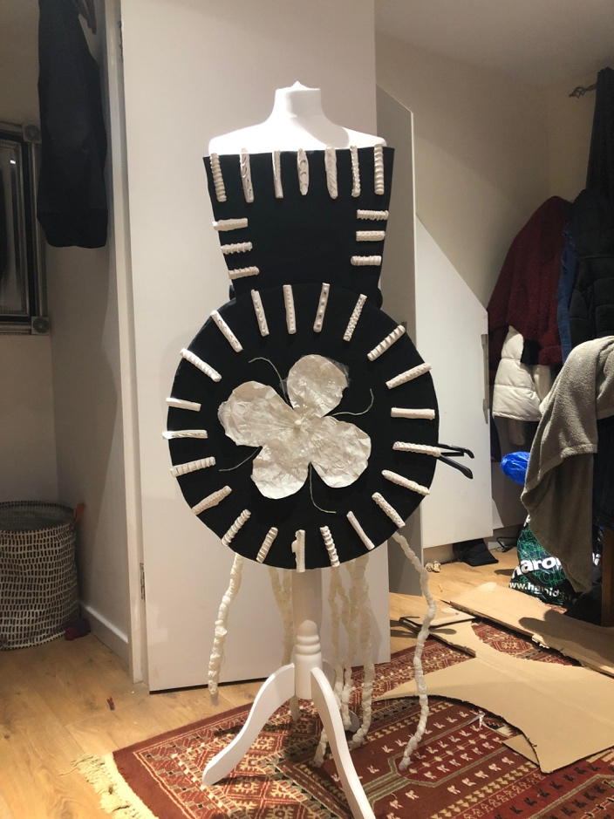

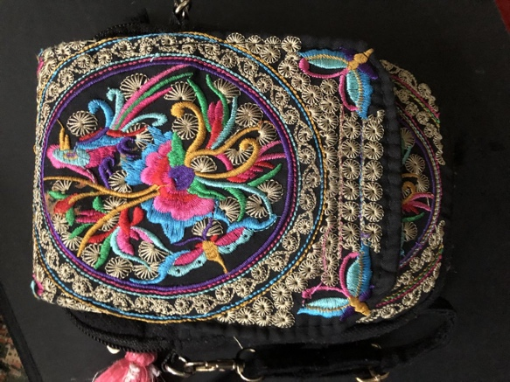

https://www.google.com/search?q=lucy+mcrae&safe=strict&sxsrf=ACYBGNQNLMvkeMB8ycr1GEPtmYrW_b91iQ:1572224540361&source=lnms&tbm=isch&sa=X&ved=0ahUKEwiE2_Dp4L3lAhXMi1wKHW1VBUsQ_AUIEigB&biw=1168&bih=1204#imgdii=Nhyr0ISHWmxCJM:&imgrc=l5Xt9CTutpbpGM:

https://www.google.com/search?safe=strict&biw=1168&bih=1204&tbm=isch&sxsrf=ACYBGNQG87DaLKGjgQiGHpVi3p8XWJ9YyQ%3A1572221903493&sa=1&ei=zzO2XfblHdeBhbIP7_uEmAM&q=Viktor+and+Rolf+&oq=Viktor+and+Rolf+&gs_l=img.3..0l10.3123519.3123519..3123932...0.0..0.57.57.1......0....2j1..gws-wiz-img.cKkdOuC6Jwg&ved=0ahUKEwi2icOA173lAhXXQEEAHe89ATMQ4dUDCAc&uact=5#imgdii=sX96PjdNOIvFhM:&imgrc=0XpvoCs-NNCgNM:

https://www.google.com/search?safe=strict&biw=1168&bih=1204&tbm=isch&sxsrf=ACYBGNQk2zswwZSAJxx8lOFQlCqxGZUwog%3A1572224548024&sa=1&ei=JD62Xf2OAeCX1fAPmNGfkAU&q=Chiharu+Shiota+&oq=Chiharu+Shiota+&gs_l=img.3..35i39j0l9.1104852.1104852..1105546...0.0..0.49.49.1......0....2j1..gws-wiz-img.fZn2LE_ZOIg&ved=0ahUKEwj9sMTt4L3lAhXgSxUIHZjoB1IQ4dUDCAc&uact=5#imgdii=0DW1-Wo5OQo3_M:&imgrc=HmiJXTD1M5WVVM:

https://www.google.com/search?q=viktor+and+rolf&safe=strict&sxsrf=ACYBGNQsJjw7z9hv6HkTgSojm6HQUibWUw:1572225920616&source=lnms&tbm=isch&sa=X&ved=0ahUKEwjI2YT85b3lAhWxoFwKHVGPCRoQ_AUIEygC&biw=1168&bih=1204&dpr=2#imgdii=wmLijU3hxj2qMM:&imgrc=HHj8qS1rl6hbEM:

https://www.google.com/search?q=viktor+and+rolf&safe=strict&sxsrf=ACYBGNQsJjw7z9hv6HkTgSojm6HQUibWUw:1572225920616&source=lnms&tbm=isch&sa=X&ved=0ahUKEwjI2YT85b3lAhWxoFwKHVGPCRoQ_AUIEygC&biw=1168&bih=1204&dpr=2#imgrc=-78Zwg8pVzW7YM:

