Image source:
- Author unknown. (2018) title unknown. Available at: https://www.instagram.com/p/Bo_n6-sgYzG/?utm_source=ig_web_button_share_sheet (Downloaded: 22 October 2018)
- Chan, I. (2018) title unknown. Available at: https://www.instagram.com/p/BpCdrKbH2wn/?utm_source=ig_web_button_share_sheet (Downloaded: 22 October 2018)
- Author unknown. (2018) title unknown. Available at: https://www.instagram.com/p/Bo9ZQ9Kg4Hg/?utm_source=ig_web_button_share_sheet (Downloaded: 22 October 2018)

Coding categories and instructions:
Location | Geographic of the taken pictures;
Amount of artworks in the picture | Amount of the artworks with an evident intention to be shown or introduced;
Amount of artists (except Marina) in the picture | Amount of the artists with an evident intention to be shown or introduced;
Amount of the term ‘the artist is present’ in the picture | Amount of the term shown in the pictures;
Presentation of the term | The methods of presenting the term including written text, slogan, poster, etc;
Presentation of the original work | The appearance of Marina’s 2010 work <The Artist is Present> and the methods of presenting it including archive video, written text, recording photos, etc;
Occasion | The event taking place shown in the picture including a general gallery visit, brand event, etc;
Amount of people in the picture | Amount of the people as the main focus in the picture;
Type of the main focus | Type of the main focus depicted, including people, objects, event, etc;
Amount of celebrities in the picture | Amount of the celebrities as the main focus in the picture;
Main action shown in the picture | The actions of the persons as the main focus shown in the pictures;
Gucci elements in the picture | The appearance of the elements of Gucci;
Sophistication of the picture | How sophisticated the pictures are, whether they are delicately taken by professionals or normal individuals;
Identity of the account stated | The identity of the accounts stated in the introduction;
Post text content summary | The main content of the text posted with the pictures;
Amount of ‘likes’ | How many ‘likes’ the posts got until collected;
Content of other hashtags | The main focuses of the other hashtags;
Amount of comments | How many comments the posts got until collected;
Preferred focus shown in the comments | The main focus shown in the comments. If the amount is too large to summarise and analyse, select the most agreed or liked ones;
Similar contents in recent posts | The similar related to the exhibition including the location, event, curator and holder, Gucci, celebrity, similar schedules and activities, etc;

‘The Artist is Present’ is a public performance by Marina Abramovic at MOMA in 2010 and is used by Gucci to title their on-going exhibition in Shanghai, themed on art appropriation and imitation. However, it takes place in a modern context when exposure and celebrity are dominating, and the luxury houses are all about little more than business.
I took an approach with coding categories in four aspects: event, people, brand effect and platform. ‘Event’ refers to the depiction of the exhibition in terms of the location, artists involved, backgrounds and display, with a link back to Marina’s original piece. ‘People’ gives an emphasis on the figures photographed, especially how they positioned themselves in a response to the exhibition and the title. ‘Brand effect’ looks particularly at how the holder, Gucci, alters the term, and makes the exhibition differ from one of normal kind. Last, ‘platform’ pays special attention to how all the aspects above, shown in the pictures, are secondarily transformed by Instagram, when they are all brought together via a hashtag.
Through the coding I am expecting to look into the alteration of the term ‘the artist is present’, affected by a modern mode of exhibiting, massive exposure from luxury brands, different attitudes towards art appreciating and the context of social network, posing a contrast against its genuine essence when first produced.

Examples (3 images selected):
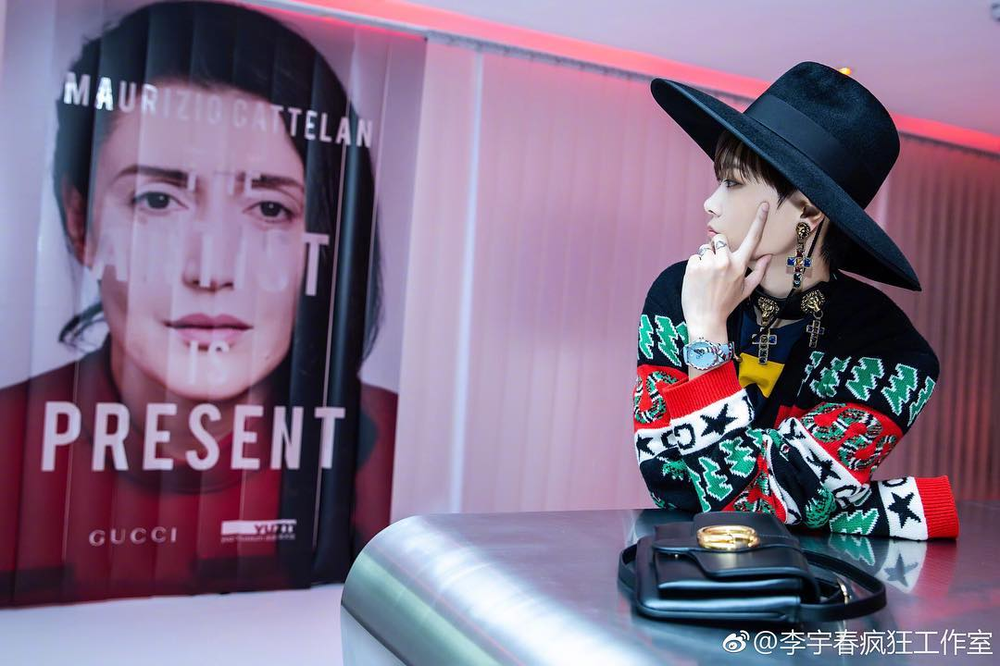
Location | Yuz Museum, Shanghai
Amount of artworks in the picture | 0
Amount of artists (except Marina) in the picture | 0
Amount of the term ‘the artist is present’ in the picture | 1
Presentation of the term | Poster
Presentation of the original work | None
Occasion | Brand visiting event
Amount of people in the picture | 1
Type of the main focus | Person; exhibition poster
Amount of celebrities in the picture | 1
Main action shown in the picture | ‘looking at the exhibition poster’
Gucci elements in the picture | Celebrity in cooperation with the brand; outfit; handbag
Sophistication of the picture | Event photograph
Identity of the account stated | Fan account of celebrity
Post text content summary | ‘celebrity attending the event; brand and curator highlighted’
Amount of ‘likes’ | 14
Content of other hashtags | Exhibition; celebrity; fashion
Amount of comments | 1
Preferred focus shown in the comments | [irrelevant]
Similar contents in recent posts | Afterward: celebrity event photographs

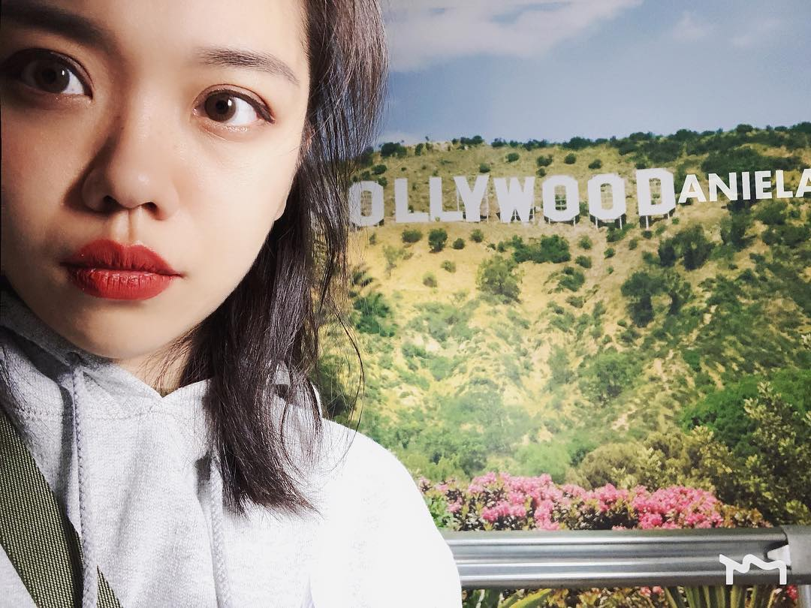
Location | Yuz Museum, Shanghai
Amount of artworks in the picture | 0
Amount of artists (except Marina) in the picture | 0
Amount of the term ‘the artist is present’ in the picture | 0
Presentation of the term | None
Presentation of the original work | None
Occasion | General visit
Amount of people in the picture | 1
Type of the main focus | Person
Amount of celebrities in the picture | 0
Main action shown in the picture | Selfie
Gucci elements in the picture | None
Sophistication of the picture | Normal
Identity of the account stated | Personal account
Post text content summary | None
Amount of ‘likes’ | 1
Content of other hashtags | None
Amount of comments | None
Preferred focus shown in the comments | Inapplicable
Similar contents in recent posts | Video recording the visit

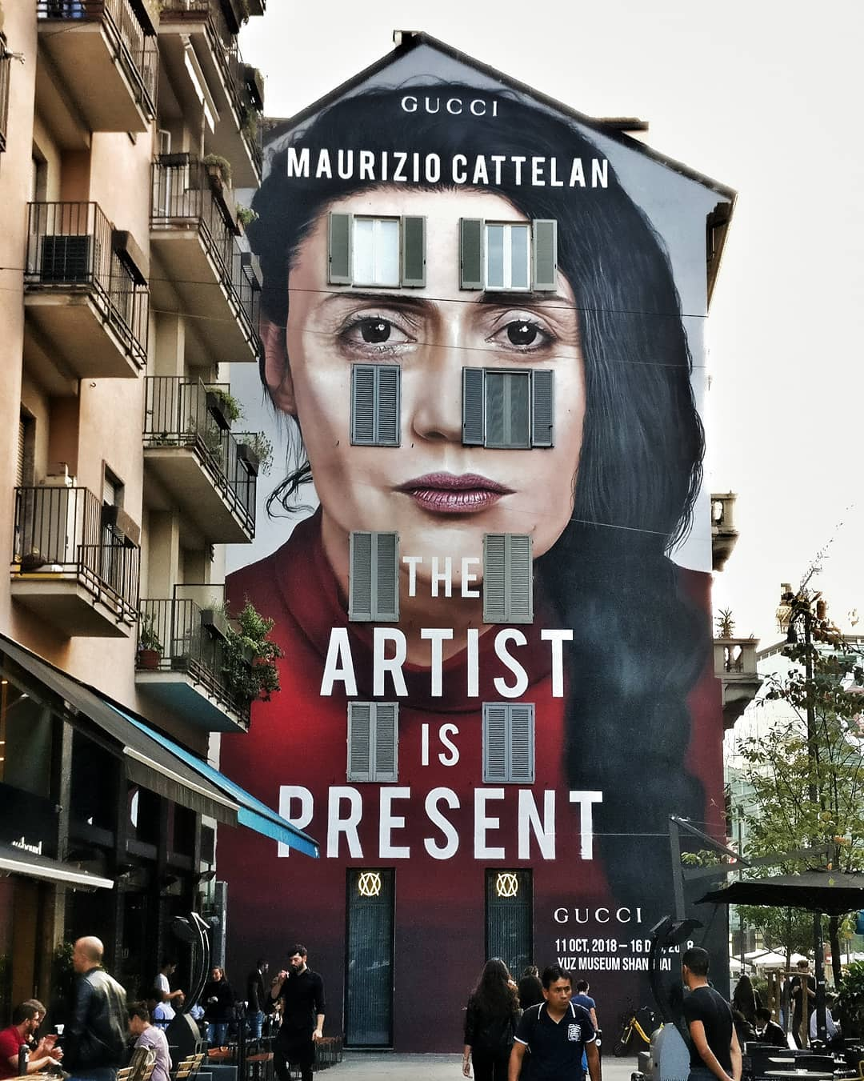
Location | Milan, Italy
Amount of artworks in the picture | 0
Amount of artists (except Marina) in the picture | 0
Amount of the term ‘the artist is present’ in the picture | 1
Presentation of the term | Street poster
Presentation of the original work | None
Occasion | Street encounter
Amount of people in the picture | Plenty
Type of the main focus | Exhibition poster on the wall
Amount of celebrities in the picture | 0
Main action shown in the picture | Normal actions on the street
Gucci elements in the picture | Exhibition holder
Sophistication of the picture | Normal
Identity of the account stated | Personal account; visual arts
Post text content summary | ‘The artist is present.’
Amount of ‘likes’ | 48
Content of other hashtags | Exhibition; brand; artist; ‘imitation’; art
Amount of comments | 2
Preferred focus shown in the comments | Praise for the picture
Similar contents in recent posts | None

Quantitative summary:
Location | Shanghai: 21  other: 6
Amount of artworks in the picture | 1: 14  0: 15
Amount of artists (except Marina) in the picture | 0: 29
Amount of the term ‘the artist is present’ in the picture | 1: 4  0: 25
Presentation of the term | Poster: 4  slogan: 1
Presentation of the original work | Video: 1
Occasion | Brand event: 3  Relevant working: 1  Visit in Shanghai: 16  Visit in other places: 3  On the street in Shanghai: 1  On the street in other places: 2
Amount of people in the picture | 4: 1  2: 1  1: 13  0: 14
Type of the main focus | Person: 15  Artwork: 9  Exhibition: 2  Poster: 3
Amount of celebrities in the picture | 1: 3  0: 26
Main action shown in the picture | Posing: 10  Selfie: 2  Other: 2
Gucci elements in the picture | Outfit and accessory: 2
Sophistication of the picture | Professional: 4  Normal: 25
Identity of the account stated | Fan account of celebrities: 3  Gucci related: 1  Public (art related): 7  Personal: 18
Post text content summary | Celebrity related: 3  Artwork related: 8  Exhibition related: 3
Amount of ‘likes’ | [unable to be listed separately]
Content of other hashtags | Exhibition related: 12  Celebrity related: 2  Fashion and brand related: 7  Artwork and artist related: 9  Marina related: 2  Concept of ‘fake and imitation’ related: 2
Amount of comments | [unable to be listed separately]
Preferred focus shown in the comments | Towards the account itself: 8  Art focused: 3  Irrelevant: 4
Similar contents in recent posts | Celebrity related: 3  Fashion and brand related: 6  Art related: 11  Irrelevant: 10

To summarize with, the analysis results from thirty samples is within expectation yet surprising, especially in the aspect of brand and celebrity. With the high exposure and under an influencing global brand it is reasonable that the term was used mainly for the exhibition. However, there are still four referring back to other artworks from Marina, the original owner of the term.
Unlike what I supposed, only three were used for posts following celebrities. Behind them are fans or fan clubs, whose accounts contain little more than the famous figures. Moreover, the image of Gucci only appears in outfits or accessories, along with two of the celebrity posts. This is unexpected, with a dominating force of fashion brands in all the relevant contents on Instagram, which itself is based on the media attention.
However, the result does accord with my assumption of a high proportion of self-concerned content. Half of the posts focus on people, who, in a way, are irrelevant, with only one exception of one woman working for the exhibition. Among them, twelve people are posing or taking selfies, making the exhibition only a background to add additional ambience. Nevertheless, among the accompanying hashtags, two of them respectively point out ‘imitation’ and ‘fake’. The core concept behind, no matter clearly revealed or not, still get noticed and paid attention to in a small scale.
Overall, accounts, personal though, specialising in certain fields have accumulated more ‘likes’ and comments. But those responses are no difference to the less-responded other. A very majority of them are plain praises or greetings with nothing extra linking back to the post or associated topics.

Conclusions drawn:
The on-going exhibition is generating active responses from the public on Instagram. But the exposure and media attention it asks for has to some extent altered the context of an exhibition, and further re-write what ‘the artist is present’ stands for. The situation worsens in that though looking enthusiastic, most of the visitors cared far more about themselves, questioning the value of public art appreciating in modern time.

