CONTEXTUAL REVIEW 2019-20

Foundation Diploma in Art and Design
Unit 3: Developing Specialist Practice

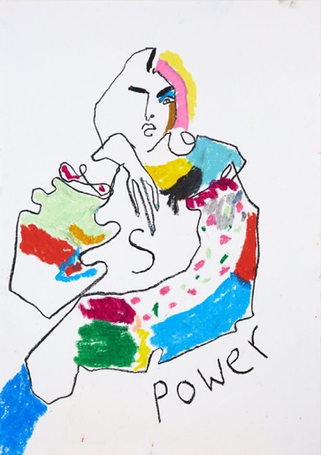 | 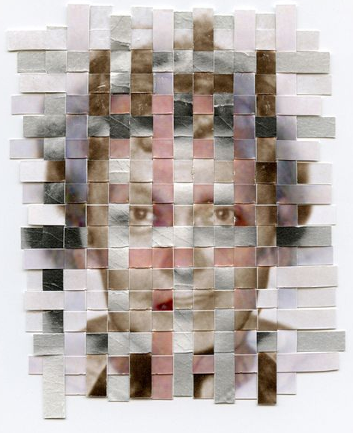 | 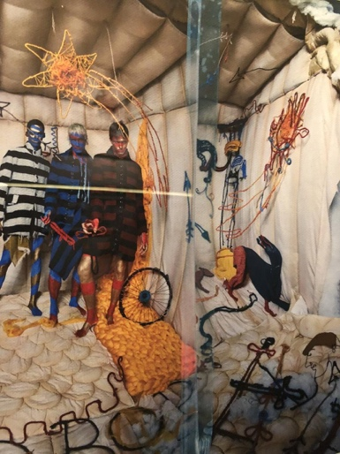
Hellen Bullock  ‘Power” | Greg Sand  ‘Remnants’ | Tim Walker  ‘Soldiers of Tomorrow’

Student Name: Liberty Blackley

750 Word Review:

Overall, I found Part 1 very engaging as I experimented with processes and learnt new skills. I have become more confident and experimental in drawing, through the illustration one day project where I was experimental with my mark making. Over this part of the course I now know I am drawn to more of the making, particularly on the body.

I am most interested in the Textiles specialism as I like the process and engaged most with the ‘Your Data’ Project. I enjoy the process and experimentation this includes; having a concept and exploring this in many different ways. I enjoy the experimental stage the most, as I like developing and adapting to make the idea more interesting and engaging as well as using a combination of materials. In this project I feel like my work flowed more, hence why I chose to extend this project. I also enjoyed the ‘Explore It’ project, where we were asked to explore how products can be elevated as it was also too very experimental as although you may have an idea in your head of how something is going to look/work, it might become completely different when it comes to the making of it and I think this is similar to textiles. However, in comparison to the two projects, although I enjoyed working in a team and to limited times when making our elevated products, I didn’t feel as engaged as there was no story behind it and I feel like in textiles although what you see may not be completely obvious, it is the concept/idea behind it that can be very useful in explaining the way it looks.

I was influenced by the Tim Walker exhibition at the V&A museum, as it features a collection of his work influenced by his personal experience of the museum itself including the costumes, jewels and the many archives that are stored there. This was really an inspiration for my extended project as I began to think about the collections personal to me that maybe I’ve never even seen physical objects of or related anything to and thinking of new ways I could explore and use them to experiment with in abstract ways. Tim Walker has an ‘acute and emotional vision’ which is inspiring as his work always has a narrative to it which is engaging. There was one particular series of photographs which reminded me of the ‘Your Data’ project, possibly because of the materials we used during the project. The knitwear by Josephine Cowell interested me as there was a sense of connectedness like so in the one-day project, she used layers and textures within her knitwear and this was exposed in the photographs produced by Tim Walker. Josephine herself explained in a video, ‘Working with Tim Walker: Stylists’ how unexpected your final outcome can be. I can really relate this to the overall view of the course as I have learnt not to be narrow minded and to think outside of the box in terms of ideas generating; what I think an idea might be in the beginning will most likely be different by the end of it and it is clear that this is how the industry of fashion styling works also. I was also inspired by Hellen Bullocks work introduced to me on the ‘Your Interpretation’ workshop. I was inspired by her work as drawing was always a process I shied away from as I always imagined drawings to be perfect however Hellen’s work has taught me that drawing can simply be mark makings, using your unique style and can also be very abstract. I was drawn to her work because of the bright and energetic colours used.

Using inspiration from the artists above, I decided to focus my extended project on my heritage. As being from England, Scotland and Jamaica I feel like I had many interesting ways of weaving and/or differentiating these backgrounds with one another. Focusing primarily on my grandparents, I began by researching into collections of family photographs over the last 90 years and collecting objects and images I found particularly interesting. I liked the self-managed nature of this project as I found myself constantly jumping between different ideas and ways of exploring my theme, however I did feel challenged in the limited amount of time given as I would have loved to have researched further into the history of my heritage and expressed this through textiles in different ways. I was influenced by the artist Greg Sand, who weaves photographs that obtain a memory of different stages in one’s life. This was a central aspect of my project as I focused on collaging images as I felt these were the main subject of my project as they obtained so much information in each photograph. This project has confirmed by belief that I am best suited to textiles as I was able to experiment using the techniques I have learnt over the course of part 1.

Bibliography

Tim Walker Exhibition
‘Wonderful Things’
Victoria and Albert Museum

Working with Tim Walker: Stylists
Video
https://www.youtube.com/watch?v=EXVQ3mRFvlI

