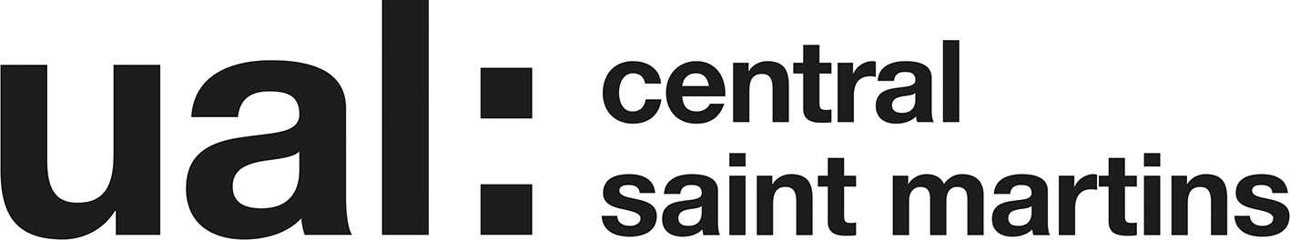 Foundation 2019-20

Foundation Diploma in Art and Design

Unit 4 Project Proposal UAL Awarding Body / CSM Foundation

Candidate Name: Alba Cruzat Candidate ID Number: 19024022

Curriculum Area: Fashion & Textiles

Pathway: Fashion

UALAB Unit: Unit 4 - Consolidating Practice.

Project Title:

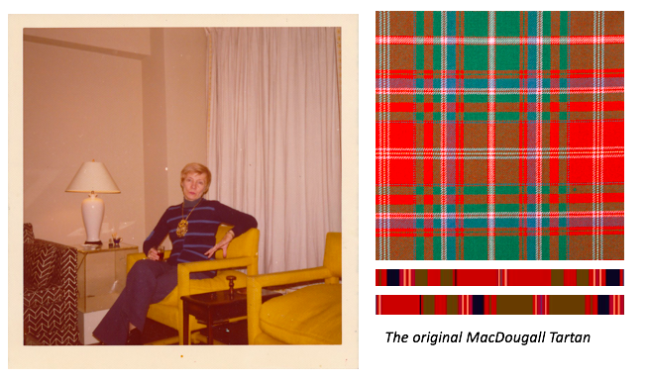
Jack of diamonds, 2012 modelling. Great great grandmother, Phillis Hill
material, foil, wire, paint, cloth, MacDougall Scottish family clan
steel and marble and plinth

Project Review
I’ve developed my understanding in how to show a strong body of work highlighting the many concepts ideas that I have explored in depth, as well as showing the process clearly communicated via drawings, relevant and carefully selected images. I've utilised a range of fabric samples using repurposed materials and a series of different use of textiles. At the beginning of the course I wasn’t very familiar with how to approach a project, especially when it came to communicate my concept in my sketchbook. Coming from a fine art background, the Fashion Pathway has given me insight in the design process of a garment. My aspiration is to redefine are relationship with clothes. The idea of how certain objects/materials have sentimental values to people is a very recurrent thing that I see in my project despite it not being obvious. It connects to them in a deeper sense as they can relate to it. I wanted to refer to something personal in this project so that it gives me insight as to what represents my identity.

Project Concept & Description

Exploring my family routes and how I align with both cultures in conjunction with me being culturally British. Looking at how there are various ways in which to explore the different forms of hybridity which can be executed through materiality or the combination of traditional and new media. I will idolise the different aspects of the cultures that I want to look further into. Drawing inspiration from my family using old photos to refer to the different cultures, as well as drawing attention to the experience of how it is as an immigrant. I come from a very diverse European and South American background; however, I don’t know much about my Scottish heritage. I’m going to explore further my Scottish Mc Dougal family heritage. Referencing their traditional family clan, the clan tartan which was designed to represent the family. I also want to push my contextual writing as I feel like I don't spend enough time on it as I tend to priorities my sketchbook. I need to consider how I can interpret the traditional craftsmanship in an innovative way with consideration of the context today as a reference of me being culturally British. The garment could consist of metaphorical references to imply the different cultures. Crossover of different cultures shown through the different assembles of textile and design.

Project Evaluation
Being consistent on research and reflection really aids the process of my project. It helped me formulate my ideas clearly and show the process of my understanding of my project clearly communicated through drawings and images. Workflow will help me understand how I am consistent with achieving my brief's objective. As well as being persistent with your sketchbook so that it is visually strong and communicated my ideas clearly. I found extremely helpful was having peer reviews regularly as it prompted what I lacked in and helped me devise my ideas further in relation to the discipline and creative context. At the end of the project, I will do a critical review referring to how it attained the project stated aims.

Proposed Research Resources and Bibliography
Artists:
Francis Upritchard
Laura Lima
Lawrence Owen Gerund
Richard Ayodeji Ikhide
Liang Wanying
Dora Maar
Evgeny Antufiev
Eileen Agar
websites:
https://www.scottishtartans.co.uk/MacDougall_Curtains_at_Dunollie.pdf

Project Action Plan and Timetable:

Throughout the whole project document, the things that you reference and draw them on a large scale

Week | Date Week  beginning | Activity / What you are intending to do - including independent study | Resources / What you will need to do it - including access to workshops
Week 24 | Feb  24th | Final Proposal Hand-in Deadline  24th -complete drawings from the exhibition that you went to visit and then select the exhibition that relates most to the beginning of your project and work from there  25th -Get personal images to refer to different cultures -research more as to what you want to look at other than your family heritage  26th -research family Scottish family heritage look at the Mc Dougall clan where my great great grandmother Agnes Hill came from  27th -continue collaging and find other artists referring to the same concepts  28th -during the weekend find materials that refer to your concept
Week 25 | March  2nd | 2nd -Produce more collages which will inform your development of your first samples -look at the artist Lawrence Owen Gerund Evgeny Antufiev Eileen Agar Scottish traditional clothing  3rd -produce some knitting samples  4th -produce some more samples weaves also transfer ink  5th Samples  6th Samples
Week 26 | March  9th | 9th Progress Tutorials This progress tutorial will inform me what I will need to plan to do for the weeks coming  10th  11th  12th  13th
Week 27 | March 16th | 16th  17th  18th  19th  20th
Week 28 | March  23rd | 23rd Begin design developments  24th  25th  26th  27th
Easter Break  Week 1 | March 30th | 30th  31st  1st  2nd  3rd | Workshops closed
Easter Break  Week 2 | April  6th | 6th  7th  8th  9th Photo shoot of final outcome  10th | Workshops closed
Week 29 | April  13th | Wed 15th Exhibition Submission  Thurs 16th Selected work to be delivered to the Lethaby KX
Week 30 | April  20th | 22nd Private View 4-9pm
Week 31 | April  29th
Week 32 | May  4th | Mon 4th Final Assessment submission  All Unit 4 work to be handed in

PROJECT PROPOSAL DRAFT - Submission Deadline Monday 10th of Feb at Part 2 Assessment.
On this date, please bring in a hardcopy print out of your draft Unit 4 Proposal and upload electronically a draft on workflow in your ‘Unit 4 documents’ section.

PROJECT PROPOSAL FINAL - Submission Deadline Thursday the 27th of Feb
Please hand in one hard copy of your final Unit 7 proposal and upload to Workflow
The Learning Outcomes for Unit 4.

Ask yourself these questions to ensure that your proposed project work will meet the assessment criteria.

1. What are the critical and contextual perspectives of your proposed project?
2. How will you research, analyse and evaluate your ideas to help develop creative solutions?
3. How will you solve complex problems through practical, theoretical and technical understanding?
4. How will you adapt and use appropriate practical methods and skills for creative production?
5. How will you use evaluative and reflective skills in order to take responsibility for your own learning, development and effective decision-making?
6. How will you critically review the effectiveness and appropriateness of your planning, methods, actions and results?
7. How will you effectively present yourself and your work to appropriate audiences?

