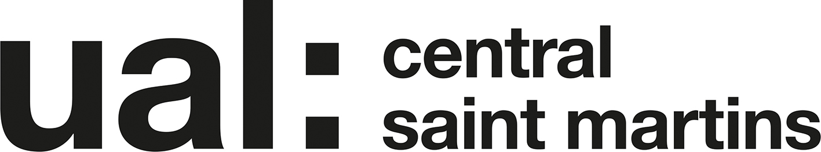 GCD 2019-20

Foundation Diploma in Art and Design
Unit 4: Consolidating Practice

Task title: The Final Evaluation

Task description: Please respond to the questions and prompts below which ask you to reflect on and evaluate the project work you have produced in Unit 4.

Submission: Save this document as follows:
Firstname_Surname_Final Evaluation.docx or
Firstname_Surname_Final Evaluation.txt

Upload to ‘GCD Unit 4 Submission’ in the GCD area of Moodle in time for the deadline of 23.59 (UK time) on Monday 4th May

Name: | Verity Hayhow
ID number: | 19005586
Pathway: | GCD Illustration and Printmaking
Project Title: | The Grass Here is Also Green

- Outline the ideas behind your work. (50 words)

My work explores the process of growing up and leaving behind one’s childhood dreams in order to become an adult. While often being forced to face the adult reality is seen as a negative thing, through my work I began to realise that in fact it is more complex than that. That loss of innocence can be heartbreaking, but it also opens our eyes to greater possibilities.

- What are your intentions for your work? Consider the following:
- SITE - Where does it exist in the world?
- AUDIENCE - Who is it for?
- IMPACT - What effect do you hope it has?
(100 words)
Although my first project was aimed at teenagers, I was afterwards drawn towards an adult audience. I wanted to investigate the complex emotions around leaving behind childhood, with all of its unrealistic dreams and aspirations, and then communicate that to the very people who would be going through those emotions. I hope that it would leave adult viewers with a desire to seek out happiness in the positions they find themselves in now, without longing for what they have left behind.
As far as where it would exist in the world: I like the idea that it could hide in ordinary life, like the Dream Cakes takeaway restaurant.

- Outline your approach to visualising the display of your work. (50 words)
I became interested in using the visual language of sweets and cake, in order to communicate the ideas I was exploring. They are a metaphor for how childhood dreams are not sustainable within adult life. As an adult we may look back on what we gave up, and feel nostalgic, but it simply isn’t healthy to dwell on their sickly sweetness.

- How has your project changed from what you initially proposed? (50 words)

I think my initial ideas needed a dose of reality. The fact is that most adults have abandoned the dreams they had as a child, and most of the next generation will do the same. This is far from a bad thing, since society needs a balanced workforce in order to function. What I learned from my interview with my grandfather was that adult life is so much more than the job you do.

- What did you learn from having to adapt your project and work with significant restriction? (50 words)

I learned how to work with what I had. For example, I didn’t actually know what I was going to do with the recording of my interview with my grandfather. Initially, it was just a piece of research to get the perspective of an older retired person on life. It wasn’t very well-planned, and I hadn’t thought very hard about the questions I asked him. But in lockdown, it became one of the few pieces of source material I had, so I cut it up and moved it around in order to become part of the animation I made.

- What impact, if any, has the current situation and working in isolation had on your work? Has it made you think differently about the purpose and meaning of your project? (50 words)

Lockdown imposed a set of practical rules that I hadn’t anticipated, for example “You can’t print anything,” or “You don’t have a lot of plain paper, so use it wisely.” More so than this, I think I found it particularly hard to stay motivated without the feedback and company of other artists.

