 Foundation 2019-20

Foundation Diploma in Art and Design

Unit 4 Project Proposal UAL Awarding Body / CSM Foundation

Candidate Name: Takashi Mitsuyuki Candidate ID Number: 18040818

Curriculum Area: 3DDA

Pathway: PDC

UALAB Unit: Unit 4 - Consolidating Practice.

Project Title: Solar Home

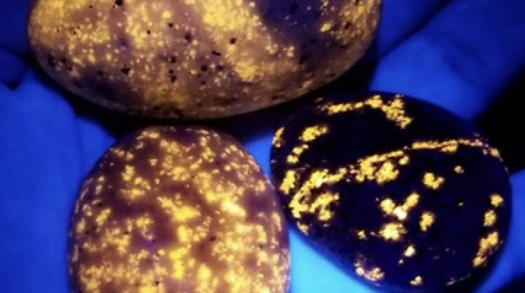
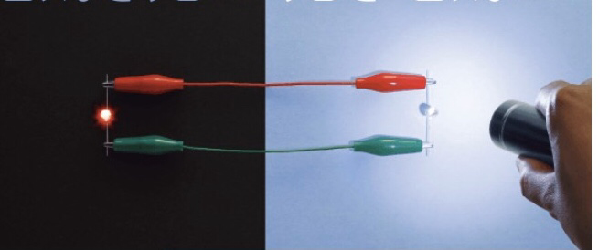
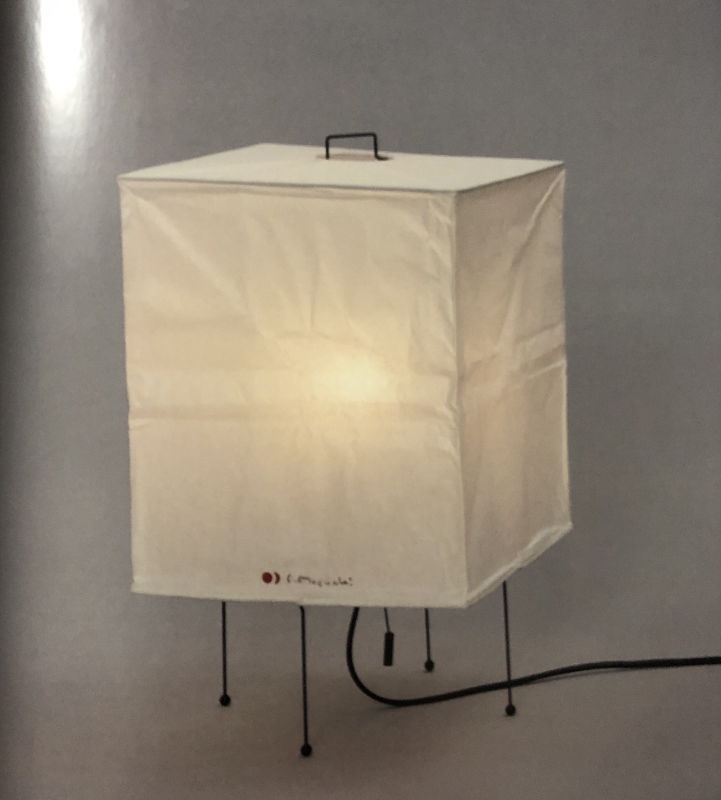
Using two LED lights. Yooperlites. Akari XP1

Project Review
In Part 2 project, I discovered some categories of product. Among them, I was interested in environmental and scientific problem. In Wild life project, I researched water problem. There are many countries which can not drink clean water. So I made a sustainable water filter which we do not need to waste. I learnt the importance of sustainability for product. Like this problem, this time I am interested in electric generation. Because I think electric is very important for human life. There are some problems about electric generation. For example, conventional power generation relying on fossil fuels causes global warming. And nuclear power harms human health when an accident occurs. So I would like to make a product which uses renewable resources.

Project Concept & Description
So I looked at the power when generating electricity. Recently, power generation methods that do not use fossil fuels, such as solar power and wind power, are increasing, but they still rely on fossil fuels. And in emergencies, renewable energy can be more useful than fossil fuelled power generation.
I am interested in some way to make power. For example, by using only two LED light, we can make electricity. If you shine light on one of the LED lights, the light will be generated by the same system as solar power, and the other light will also shine. And I know that I can make batteries by using coil , fruit and charcoal. And there are Yooperlites which can glow. I think these system are very sustainable and can be used for indirected lighting.
And I am interested in the relationship between light and Washi. Like” Akari XP1”, I want to design something with warm atmosphere for the home. I want to design for the home because most of the time we are in our homes. A warm atmosphere is important because when we are in winter, living alone, it is easy to feel sad, but a warm light makes you feel good. I think the visual and psychological information are important for design. Colour is known and can help people to feel relaxed, calm and feel more ‘at home’. It’s important that the product is good for the environment to reduce waste, and I think designers should make not only beautiful design but also environmentally friendly design.

Project Evaluation
In this project, I will use workflow as my avatar. I will record my thinking, emotion and what I do. And Using workflow, I will re-structure my opinion and process. Sometimes my research and process of making products are not good because I want results first. But I think that it will be solved by using workflow and performing it systematically.

Proposed Research Resources and Bibliography (Harvard format)

Diverse and contemporary references, with notes where helpful to help students find relevant material (librarian Beth will support with suggestions by email b.e.thompson@csm.arts.ac.uk and staff or students can email ASK for support with research, http://arts.ac.libanswers.com/)

Books
Harvard referenced (https://www.harvardgenerator.com/)
Rass, T. and H, T., 2010. Sustainability and design ethics. 1st ed. Florida: CRC Press.
Cuffaro, D., Blackman, C., Paige, D. and Laituri, D., 2013. Industrial design. 1st ed. USA: Rockport Publishers.
Brower, C., Mallory, R. and Ohlman, Z., 2009. Experimental Eco design. 1st ed. Switzerland: RotoVision SA.
Vallero, D. and Brasier, C., 2008. Sustainable design. 1st ed. Canada: John Wiley & Sons, Inc., Hoboken,New Jersey.
Stankovic, S., Campbell, N. and Harries, A., 2009. Urban Wind Energy. 1st ed. The UK and USA: Earthscan.
Prasad, D. and Snow, M., 2005. Solar Power. 1st ed. Australia: The images Publishing Group Pty Ltd and Earthscan.
McVeigh, J., 1997. Sun power. 1st ed. London: William Clowes & Sons, Limited.
Japan Industrial Designers’ Association., 2019. Basic of Product Design. 3rd ed. Japan: Toru Murakami, p.176.
Binder, B., 2013. Lightopia. Vitra Design Museum.
Koch, A., 2012. Morden Lighting Of The’50’s (german And English Edition). Arnolodsche Verlagsanatalt.
Malcom, I., 2012. Lighting For Interior design. Laurence King Pub.
Marin, M., 2004. Only Lights. atrium Publishers group.

CSM Library Shelf marks to browse
(Shelf marks can be found here http://arts.ac.libguides.com/?b=g&d=a
Search with key words, refine to the CSM library, select books from the tabs)
Sustainable design
Eco/Sustainable Architecture
Environmental aspects Building integrated photovallic systems
Solar energy
Wind power
Urban ecology
Sustainable architecture
Industrial design
Environmental aspects
Lighting
Exhibition
Lighting, Architectural and decorative
Electric Lighting

Journals / eLibrary resources
(These can also be found here http://arts.ac.libguides.com/?b=g&d=a
Search with key words, refine to the CSM library, select eResources from the tabs)
Sustainable materials on Materials and Products by Billie Coxhead | Subjects Materials | Search Score 70.59
JPN:Sharp Introduce ‘Lumiwall’ [electronic resources]. Publisher:Britannica
High-Efficiency,High-Power AlGaInP Thin-Film LEDs with Micron-Sized Truncated Cones as Light-Extraction Structures [electronic resources]. Publisher: Electronic and Photonics Research Institute
Automatic Generation Control of an Organic Rankine Cycle Solar-Thermal/Wind-Diesel Hybrid Energy System[electronic resources]. Publisher:Electronic Engineering Department, National Institute of technology Silchar, Assam(India)
Maximizing your Lighting Systems[electronic resources]. Publisher:Rettich, Kevin C. Hoyle, Terry
Strange Case of Signor Volta and Mister Nicholoson: How Electrochemistry Developed as a Consequence of an Editorial Misconduct [electronic resources]. Publisher: Prof.Luigi Fabbrizzi
The story behind glow in the dark ‘Yooperlites’ found in Michigan[electronic resources]. Publisher:Marina Cracchiolo
Davidpompa pairs pink volcanic rock and copper for Ambra lamp range [electronic resources]. Publisher:Eleanor Gibson, dezeen
Workstead’s Orbit lights feature movable metal reflectors [electronic resources]. Publisher:Alan G Brake, dezeen
Haberdashery proposes Gelio Ray urban reflectors to bring light into shaded street [electronic resources]. Publisher:Ali Morris, dezeen
Foster+Partners introduces Eva tabletop light with candle-like glow [electronic resources]. Publisher: Rima Sabina Aouf, dezeen

Practitioners
Full Name – notes
Tomas Edison-designed Incandescent light bulb
Samuel Wilkinson-designed Plumen 001 light bulb
HULGER-designed Plumen 001 fluorescent light bulb
Lee Broom-designed Crystal Build LED light
Moritz Waldemeyer -designed My New Flame LED lamp
Ingo Maurer-designed My New Flame LED lamp
Margarete Schutte -designed The Frankfurt Kitchen
Transglass -product company which uses recycled bottles
Luceplan -lighting design group
John Nicholson-designed LuxCorp furniture
Dr. Kathy Takayama -designed LuxCorp furniture
Alessandro Giuseppe Antonio Anastasio Volta-designed Volta battery
Design studio Davidpompa -designed pair of wall and table lights
Brookly studio Workstead -designed a range of light fixtures with brass disc-shaped reflectors
Haberdashery-designed huge urban reflectors
Foster+Partners-designed Eva tabletop light with candle-like glow
George Nelson-designed Bubble Lamp H-734, Angled Sphere
Isamu Noguchi-designed Akari XP1,Table lamp
Middletown Manufacturing Comp.-designed Desk lamp
Heifely Manufacturing Co-designed Lamp with black steel tube base, Table lamp
Tokujin Yoshioka -designed ToFU
Gerrit Rietveld -designed L 40, Tubular lamp or Hanging lamp
Pierre Chareau -designed LP 166, Ia Fleur
Charles-Edouard-designed LC-MU-13-A
Joe and Gianni Colombo-designed No.281, Acrilica

Visits including museums, shops, exhibitions, etc.
Location, nearest tube, address, entry fee, opening times
•The Design Museum High Street Kensington station 224-238 Kensington High Street London W8 6AG England ,free, 10:00~18:00
•Missiongreen 182 Hither Green Lane, Hither Green, London, SE13 6QB, United Kingdom Hither Green station
Opening time Wednesday CLOSED, Saturday 10:00 to 18:00, Sunday 11:00 to 16:00, Other days 10:00 to 19:00
•Science Museum, South Kensington station, Exhibition Road South Kensington London SW7 2DD England, free, 10:00~18:00
•Haibara
2-7-1-chome Nihombashi, Chou-ku, Tokyo Tokyo Nihombashi Tower, 1030027,Japan
Nihombashi station (Gonza line, Tozai line, Toei Asakusa line)
(OPEN) Mon~Fri. 10:00~18:30 Sat~Sun. 10:00~17:30
(CLOSE) Public holidays

Project Action Plan and Timetable:

Week | Date Week  beginning | Activity / What you are intending to do -  including independent study | Resources / What you will need to do it - including access to resources
Week 23 | Feb  17th | Independent Research Week  Research | Library  Museums
Week 24 | Feb  24th | Final Proposal Hand-in Deadline  Research  Write proposal | Library  Museums
Week 25 | March  2nd | Start making  Test model | Workshop
Week 26 | March  9th | Progress Tutorials  Making  Test the movement of lighting system  Research lighting system | Library  3D workshop
Week 27 | March 16th | Making real size model  Test the brightness of light | 3D workshop
Week 28 | March  23rd | Making  Think about the relationship between light and colour | 3D workshop
Easter Break  Week 1 | March 30th | Research  Making | Workshops closed
Easter Break  Week 2 | April  6th | Research  Making | Workshops closed
Week 29 | April  13th | Tue 14th Photo Shoot  Wed 15th Exhibition Submission  Thurs 16th Selected work to be delivered to the Lethaby KX | Finish making
Week 30 | April  20th | 22nd Private View 4-9pm
Week 31 | April  29th
Week 32 | May  4th | Mon 4th Final Assessment submission  All Unit 4 work to be handed in

