

Unit 4: Project Proposal 2019-20 UAL Awarding Body / CSM Foundation

Candidate Name: Rose Draper Candidate ID Number: 19026622

Curriculum Area: Fine Art

Pathway: 4D

UALAB Unit: Unit 4 - Consolidating Practice

Project Title: ‘Smiling Inside Out’

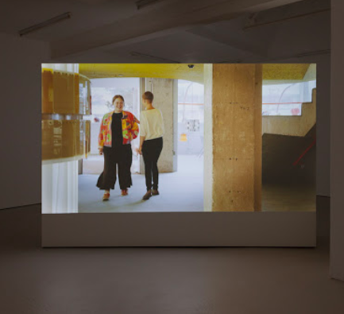 | 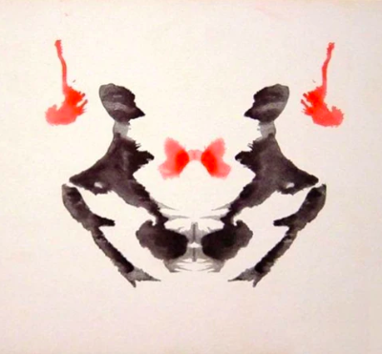 | 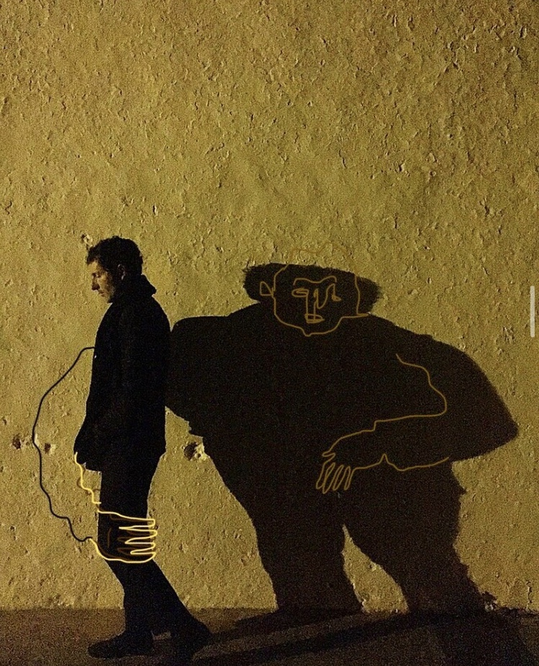

Pilvi Takala  The Toucher  2018 | Hermann Rorschach  Rorschach test  1921 | Simon Buret  ‘You have a silent twin’  2019

Section 1: Project Review

During the diagnostic course leading to a specialism in Fine Art - 4D I have used a huge range of methodologies and mediums to push my concepts into interesting visuals. I like my work to explore expression across many dimensions (2D, 3D, 4D) without physical impossibility holding it back. For this reason and with my new capabilities on Premiere Pro, I have found that experimenting with video is an exciting way to express my concepts, using a combination of the visual and audio. This use of sound within work has allowed me to express myself through spoken word. I find this very exciting because I have recently been expressing my ideas through short abstract written pieces and poetry. I have also found that including video work within the physical world can allow pieces to explore space and produce attention demanding abstract dimensionally contradictive imagery.

As well as video outcomes, I like to use tactile processes that take place in the real world, with a hands on approach to progress my work forwards. I like to produce pieces that catch the eye of the viewer, pose questions in their mind and provoke conversation amongst those around them.

The aim of this project is to aid in the understanding that people’s outward projections are not the same as their inner selves. I want to help people stop comparing their insides to other people’s outsides.

Section 2: Project Concept & Description

In this project I want to explore the duality of the physical and abstract selves. I want to examine how a state of mind can be extended to create an atmosphere in physical space. Looking at the effects on space as an extension of the self, through abstracting the expectations of spatial directionality. The spaces of the mind can be visualised or represented by personal, familiar, real world spaces, by distorting their structures into the non-spatial directionality that the spaces of the mind have.
I intend to research Pilvi Takala’s ‘The Toucher’ further and look into ways that emotional, intangible aspects of life can affect the tangible. Before the toucher entered the room there was a certain atmosphere. How was that atmosphere shifted by her temporary presence once she had left the space? I want to explore personal, familiar spaces/ rooms and re-express them in abstract experimental ways.
I hope to explore how this duality of the self can be visually expressed through experimentation with light and shadow. I plan to explore the symbiosis of their relationship. I could use a medium which looks into this through the use of three dimensional line, like Alexander Calder’s wire work.
The mind is a very personal, closed off thing. Something full of mystery, questions and lack of understanding, so I think it’s really interesting to be relating something of this nature with a room. A space that can be entered and explored.

Section 3: Project Evaluation

I find that my thoughts have much better order and fluidity when hand written, so I will use a small diary to reflect my thoughts throughout this project. I can then use this diary to go back through and pick out lines I feel are important to me and use these to start writing poetry to express as spoken word in my video work.

I aim to use my sketchbook as a place to explore potential future visuals, plan the complexities of each piece and figure out how realistic certain structures are to make. I will also use this as a space to critically reflect and deepen the conceptual understanding of my pieces. I aim to share my work more with those around me so I can take in their feedback and see where that guides my work.

Section 4: Proposed Research Resources and Bibliography

BOOKS

Benson, N, Collin, C , Ginsburg, J, Grand, V, Lazyan, M, Weeks, M, Tomley, S. 2011. The Psychology Book. Publisher: DK Publishing (Dorling Kindersley).

Leader, D, Zeki, S, Bucklow, C, Onians, J, Jaron, S. 2019. Bacon and the Mind: Art, Neuroscience and Psychology. Publisher: Thames & Hudson Ltd.

Ralls, E, Riggs, C. 2019. The Little Book of Psychology: An Introduction to the Key Psychologists and Theories You Need to Know, Publisher: Summersdale Publishers Ltd.

Poulton, R. 2019. The Little Book of Philosophy: An Introduction to the Key Thinkers and Theories You Need to Know, Publisher: Summersdale Publishers Ltd.

Buckingham, W, King, P, J, Burnham, D, Weeks, M, Hill, C, Marenbon, J, Tomley, S. 2011. The Philosophy Book. Publisher: DK Publishing (Dorling Kindersley).

Jean, B. (1981). Simulacra and Simulation. Publisher: University of Michigan Press

WEBSITES

YouTube. (2020). Alan watts – Falling into love. [online] Available at https://www.youtube.com/watch?v=5Uhahu0Pos4 [Accessed 11 Feb. 2020].

YouTube. (2020). Bruce Lee Be As Water My Friend. [online] Available at https://www.youtube.com/watch?v=cJMwBwFj5nQ [Accessed 11 Feb. 2020].

YouTube. (2020). [1973] “Not I” (Samuel Beckett). [online] Available at https://www.youtube.com/watch?v=M4LDwfKxr-M&t=208s [Accessed 11 Feb. 2020].

Urdesignmag. (2020). SPIRALALALA – Szczecin Philharmonic / PanGenerator – Undesignmag. [online] Available at: https://www.urdesignmag.com/art/2018/11/13/spiralalala-pangenerator/ [Accessed 12 Feb. 2020].

Calder.org. (2020). CALDER FOUNDATION | WORK | BY CATEGORY. [online] Available at http://www.calder.org/work/by-category/wire-sculpture [Accessed 12 Feb. 2020].

Danatrippe.com (2020). [online] Available at: https://www.danatrippe.com/ [Accessed 22 Feb. 2020].

ScienceDaily. (2018). The creative brain is wired differently. [online] Available at: https://www.sciencedaily.com/releases/2018/01/180117163954.htm. [Accessed 22 Feb. 2020].

EXHIBITIONS

Somerset House, ‘24/7’. Thu, 31 Oct 2019 – Sun, 23 Feb 2020

Slices of time, now gallery (Greenwich). 5th Feb – 19th April

Moving to Mars, Design museum (Kensington). Ends 23rd Feb

Tim Walker: Wonderful things, V&A (Knightsbridge). Ends 8th March

Alice in Wonderland, V&A (Knightsbridge). From 27th June

The habitat of time, curated by Julie Louis Bacon, Arts Catalyst, (Kings Cross) 20th Feb – 14th March. (Free)

Section 5: Project Action Plan and Timetable:

Week | Date Week  beginning | Activity / What you are intending to do - including independent study | Resources / What you will need to do it - including access to workshops
Week 23 | Feb  17th | Independent Research Week
Week 24 | Feb  24th | Explore imagery within the 2nd dimension.  Final Proposal Hand in Deadline – 27th Feb | Collage supplies (magazines, tactile bits and bobs)  Painting supplies (acrylic paint(fast drying), brushes/ pallet knives, source imagery.)
Week 25 | March  2nd | Explore real depth within the 3D world. | Wire, other materials I find suitable for my imagery in the sculpture world.
Week 26 | March 9th | Progress Tutorials  Explore real depth within the 3D world. | Wire, other materials I find suitable for my imagery in the sculpture world.  Learn how to print images onto materials.
Week 27 | March 16th | Explore false depth within the 4D world. | Play around with changing touch into sound.  Experiment with suitable imagery.
Week 28 | March  23rd | Explore false depth within the 4D world and incorporate this into your real world pieces to give a state of contradiction. | Patience.
Easter Break  Week  1 | March 30th | Bring together all previous work in to a real world collaborative instillation. | Patience.
Easter Break  Week  2 | April  6th | Bring together all previous work in to a real world collaborative instillation. | Patience.
Week 29 | April  13th | Lethaby Exhibition Submission on the 15th  Selected work to be delivered to the Lethaby KX  16th
Week 30 | April  20th | Lethaby Private View 4-9pm 22nd April  Install Park work  Park open to public 23rd – 26th April
Week 31 | April  29th
Week 32 | May 4th | Final Assessment submission. Time TBC.

PROJECT PROPOSAL DRAFT - Submission Deadline Monday 10th of Feb at Part 2 Assessment.
On this date, please bring in a hardcopy print out of your draft Unit 4 Proposal and upload electronically a draft on workflow in your ‘Unit 4 documents’ section.

PROJECT PROPOSAL FINAL - Submission Deadline Thursday the 27th of Feb
Please hand in one hard copy of your final Unit 7 proposal and upload to Workflow

The Learning Outcomes for Unit 4.

Ask yourself these questions to ensure that your proposed project work will meet the assessment criteria.

What are the critical and contextual perspectives of your proposed project?

How will you research, analyse and evaluate your ideas to help develop creative solutions?

How will you solve complex problems through practical, theoretical and technical understanding?

How will you adapt and use appropriate practical methods and skills for creative production?

How will you use evaluative and reflective skills in order to take responsibility for your own learning, development and effective decision-making?

How will you critically review the effectiveness and appropriateness of your planning, methods, actions and results?

How will you effectively present yourself and your work to appropriate audiences?

