Civil war

I was quite impressed by the reality of refugee especially their life which inspired me a lot. They live a difficult life in different locations, moving one place to another with a lot of burdens to escape from war or persecution. Even though it isn?t any of their fault they are almost forced to flee their home and there are not many countries to welcome and accept them. I think they are the biggest victim of wars. I will be researching about their life.
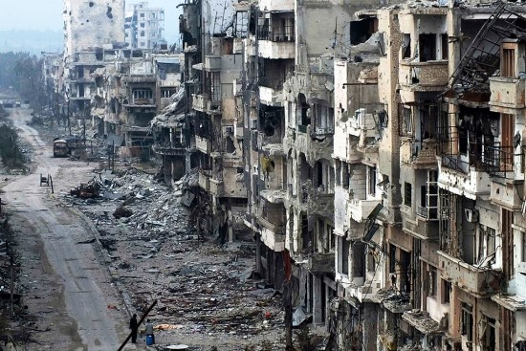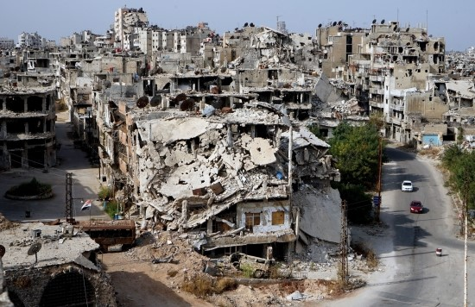
Damaged buildings in the city by civil war

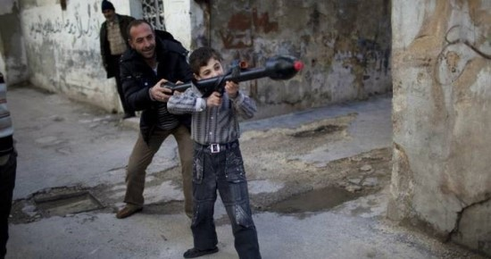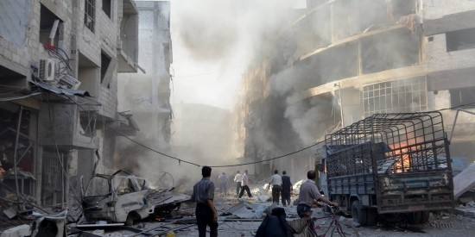

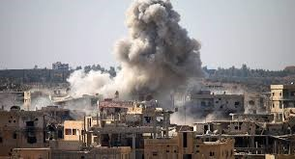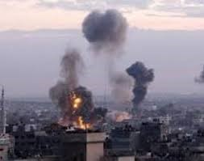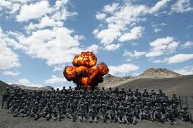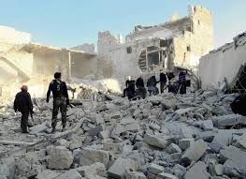
Various shape of smoke after explosion
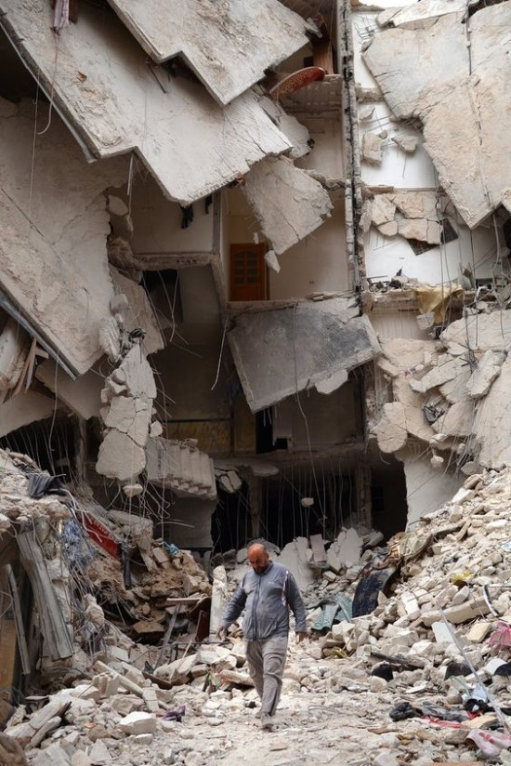

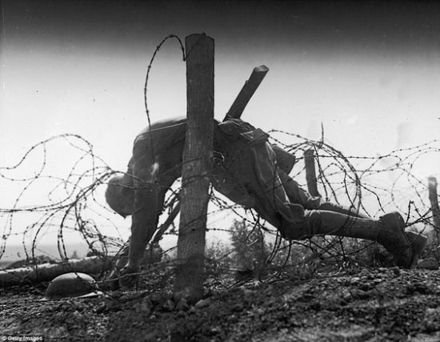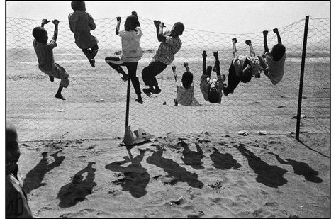
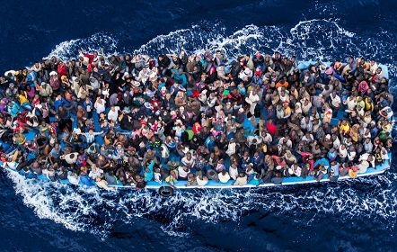

There are many people forced to escape from their country and injured and ,worst of all, lost their dear family member..

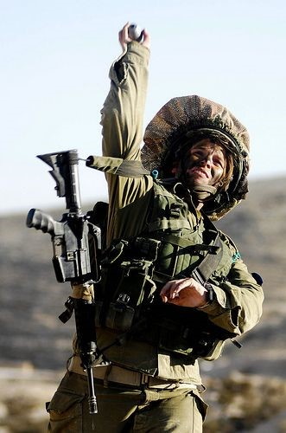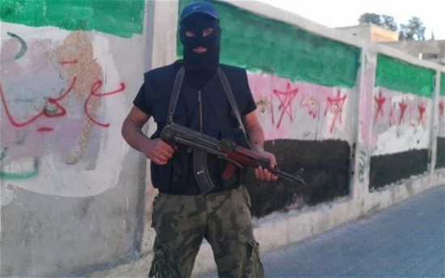

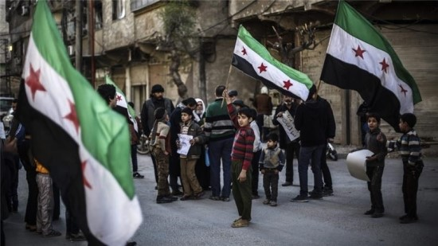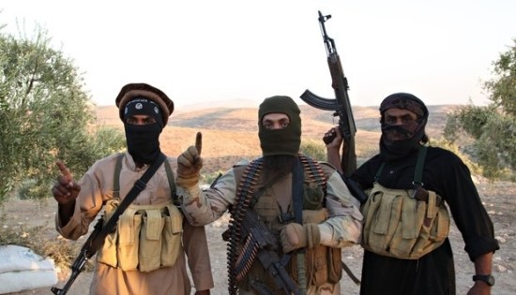

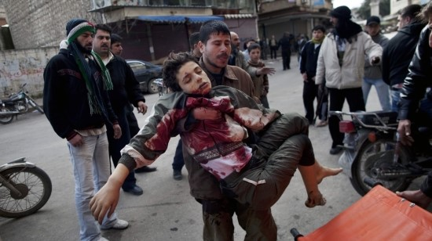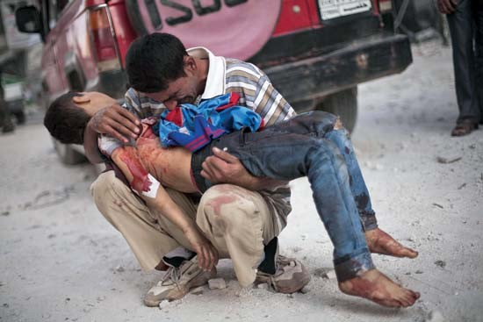
There is no word to describe their sadness when they lost their dear children..screaming.
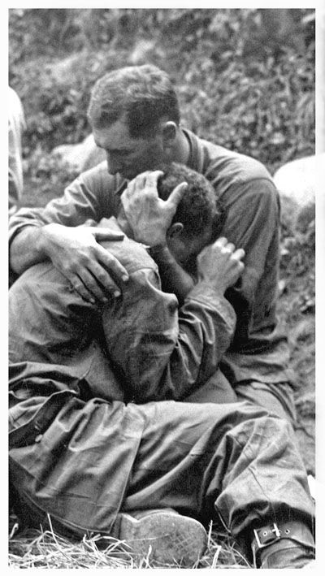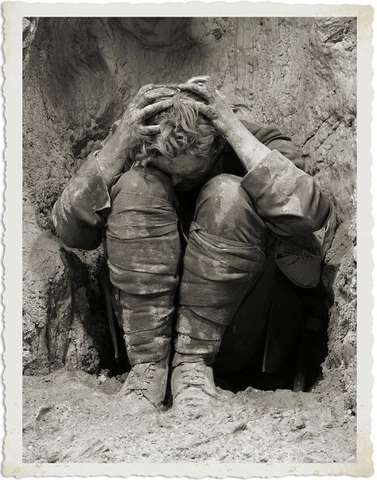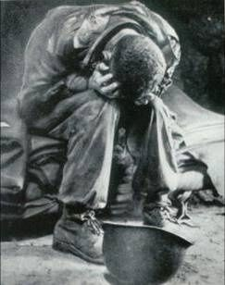

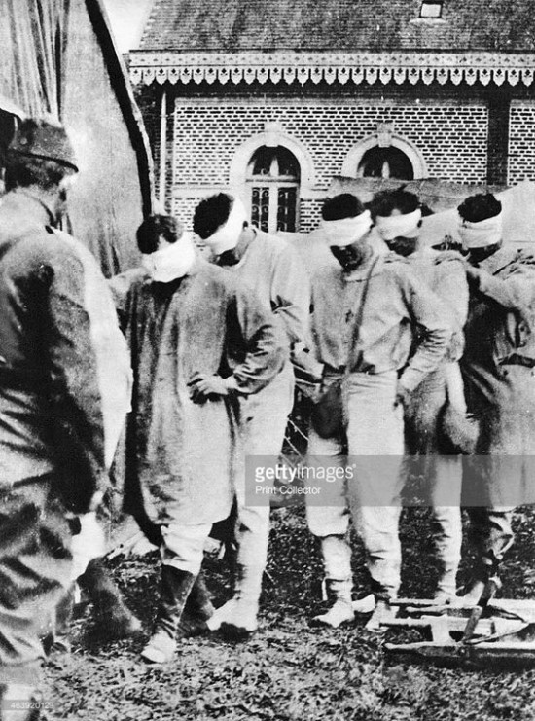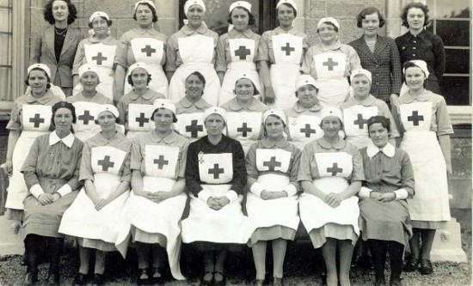
I was quite interested by the nurse costume in the war. they are wearing pinafores and Cross mark on the body

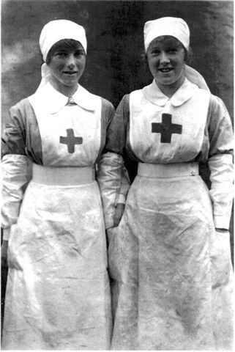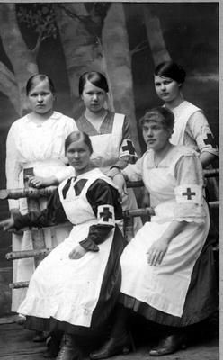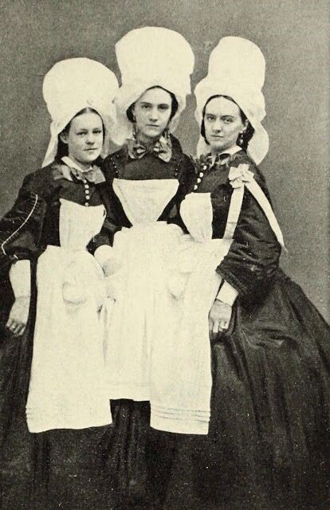
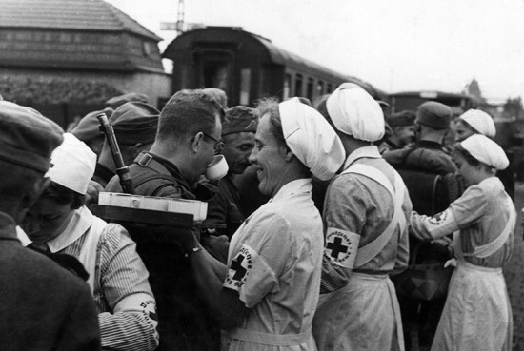

Refugee, migrant, defector

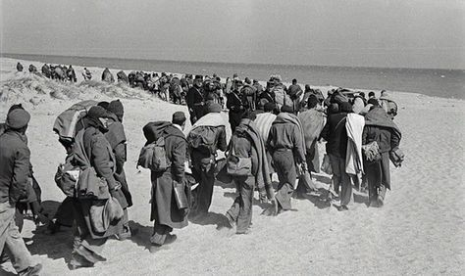
There are a lot of people escaping from their country, moving one location to another with a lot of burdens.
Every people have different amount of burdens and that make some interesting shapes.

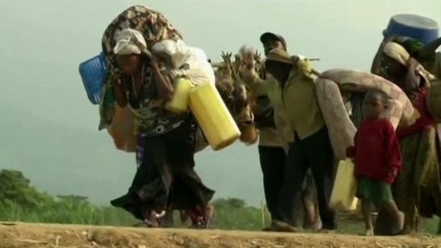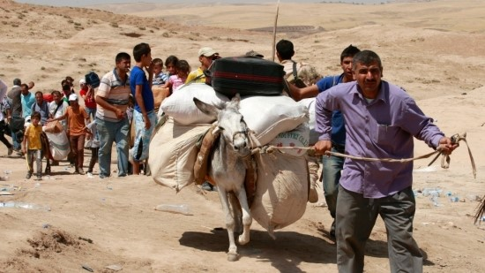

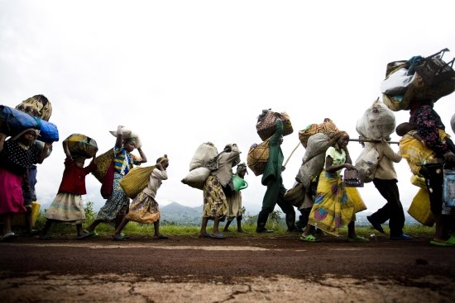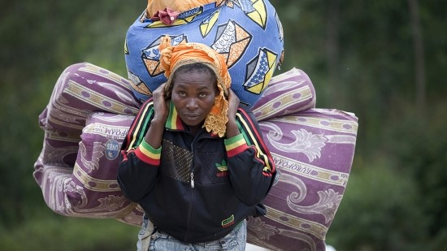
Interesting shape of the burdens with duvet and any other thinks which the above women is carrying.
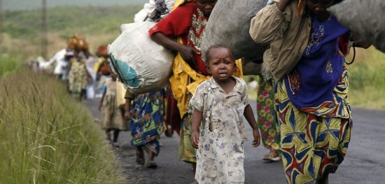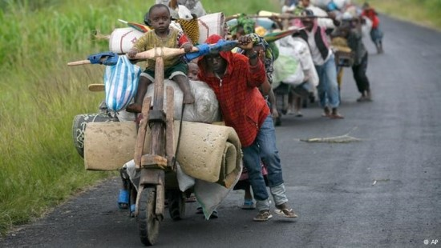

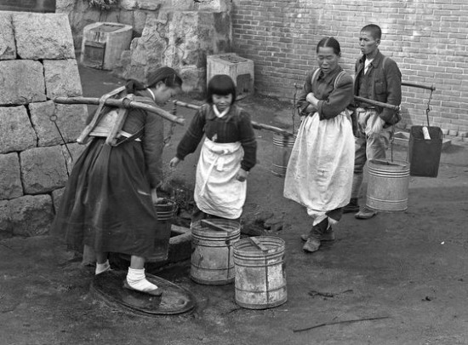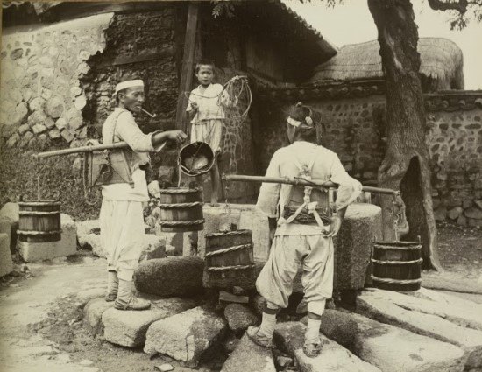
In Korea ,long time ago, they usually get the water which is drawn from a well and the stuffs they are carrying to move the water looks interesting.

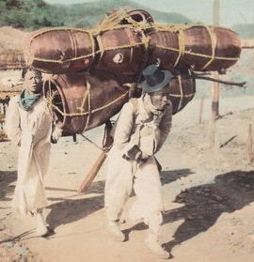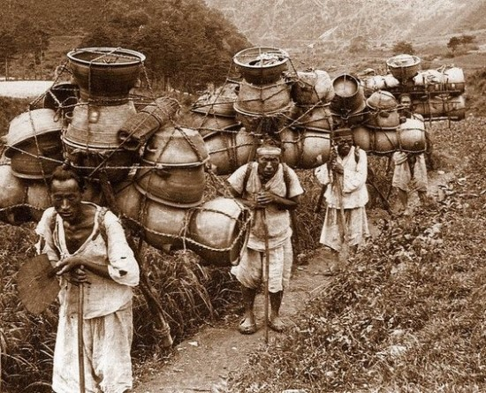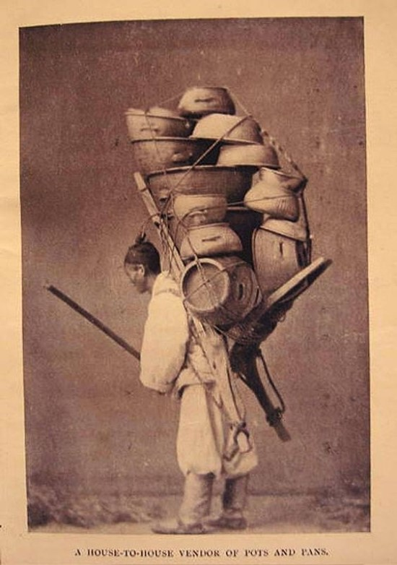

A loads of guys get a living by selling various stuffs which they manipulated or cultivated in the market.
Many people use korean A-frame to bring them.

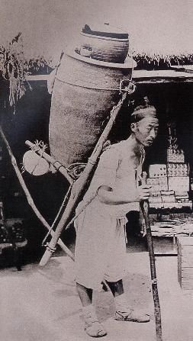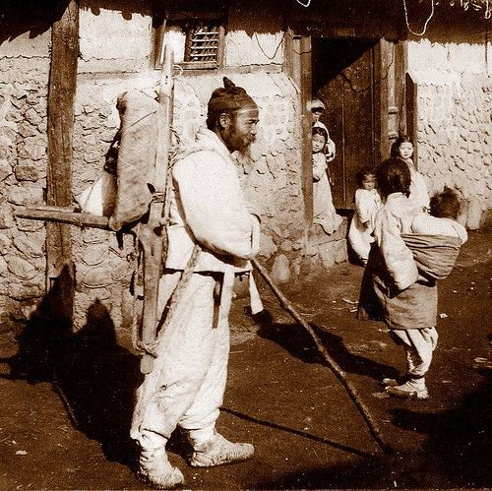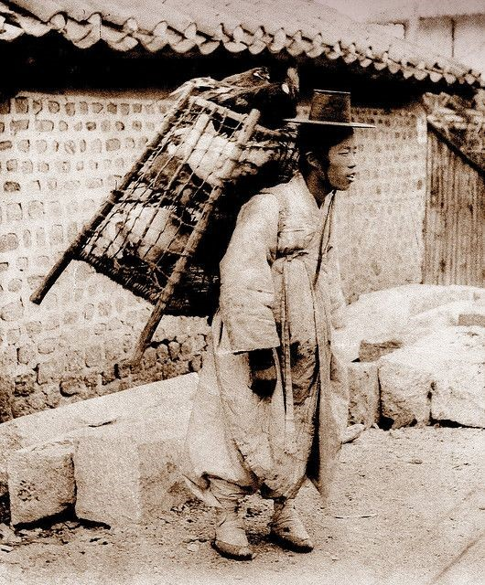

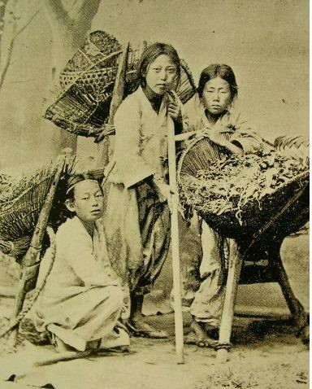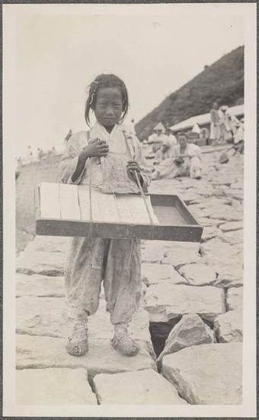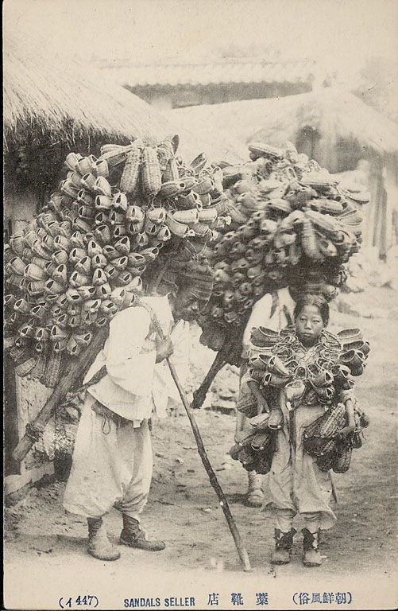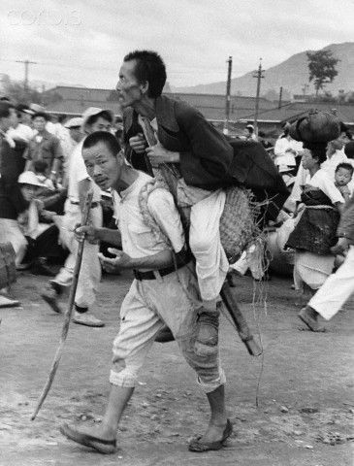

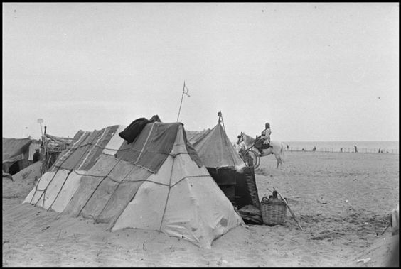
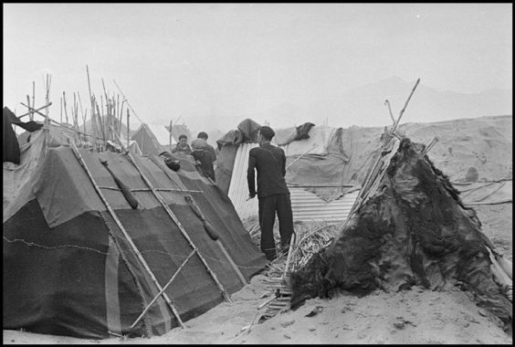

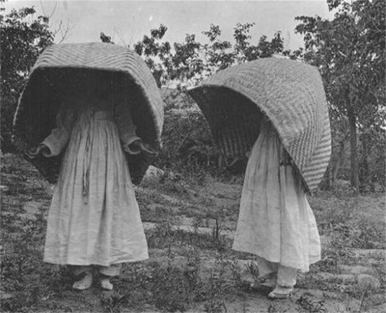
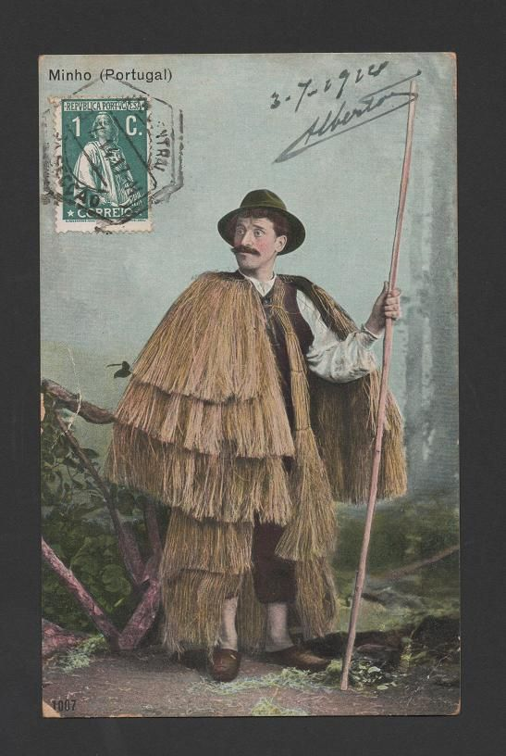

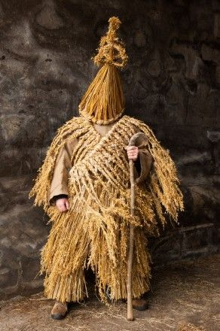

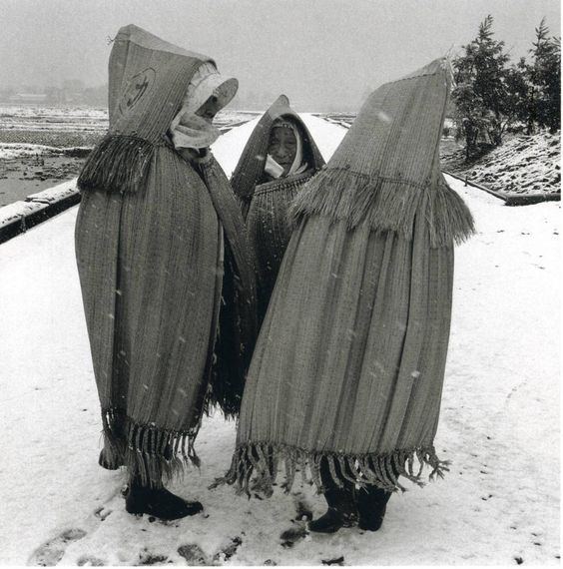
It looks like they are wearing tent on the head. It's quite interesting shape.

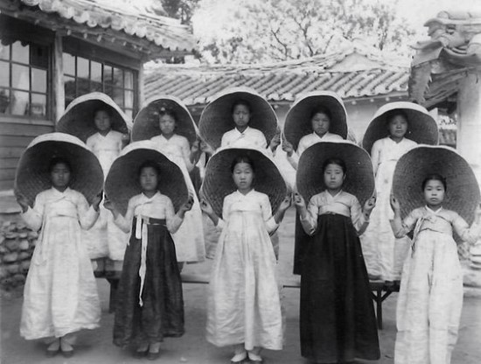

They are carrying something over their shoulder and sell the Korean hard taffy.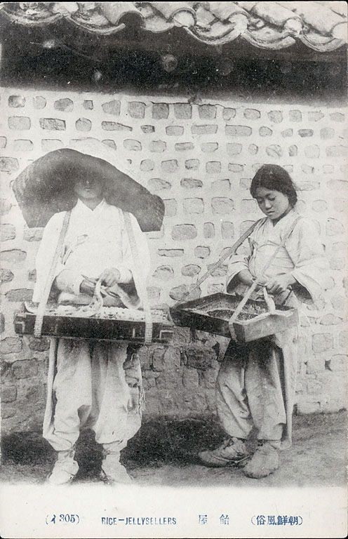 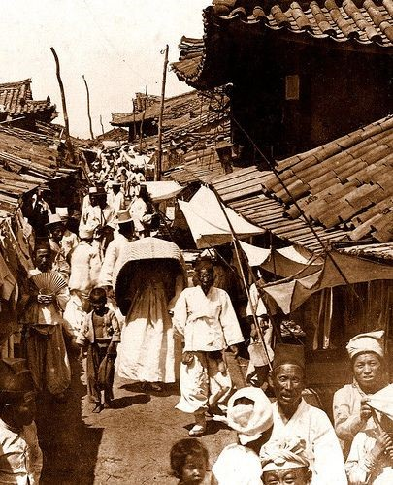

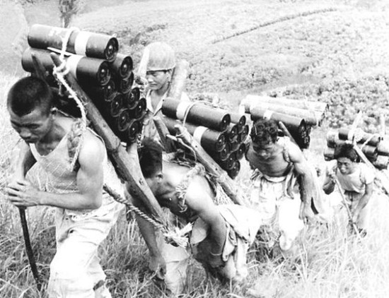

Lucy Orta-refugee wear

Refuge Wear (1992-98), are temporary shelters and architectures that can be transformed into clothing to offer protection from harsh conditions and shelter in emergency situations. The series, which Lucy Orta began working on during a period of economic recession provoked by the Gulf War and subsequent stock market crash, combines a dual response to this unprecedented global crisis. They are poetic responses to the humanitarian aid appeals for shelter and clothing to help the Kurd refugees fleeing the war zones, and to the increasing numbers of homeless people on the streets of Paris. Refuge Wear are portable habitats that convert into anoraks and backpacks, designed for personal comfort and mobility for nomadic populations.
The transformation from shelter to clothing and vice versa is fundamental to the concept of freedom of movement, free will or choice, new relationships and new cultural exchanges, the homo mobilis. They incorporate arm and hood appendages, or pockets that contain both functional and symbolic objects. Their ergonomic forms allow for a minimum vital body space and they employ cutting-edge design innovations such as telescopic carbon armatures that raise the fabric above the chest to eliminate the effects of claustrophobia. The materials contain technical properties such as microporous Rip Stop with or PU coatings, metaphors for body comfort and protection. Throughout the 1990's Lucy + Jorge Orta staged public interventions to challenge acts
of social disappearance and to render the invisible populations, visible once more. Peripheral urban spaces such as squats, railway stations, housing projects, bridges and subways were chosen as arenas for simultaneous happenings.

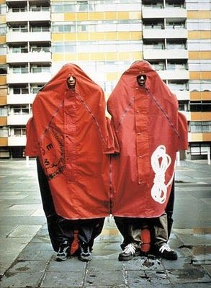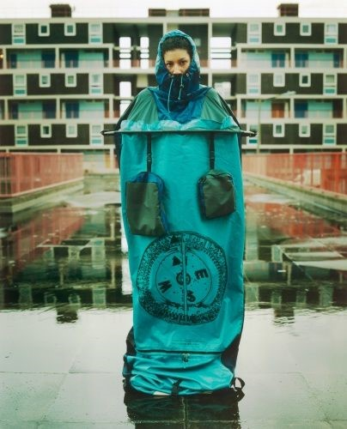
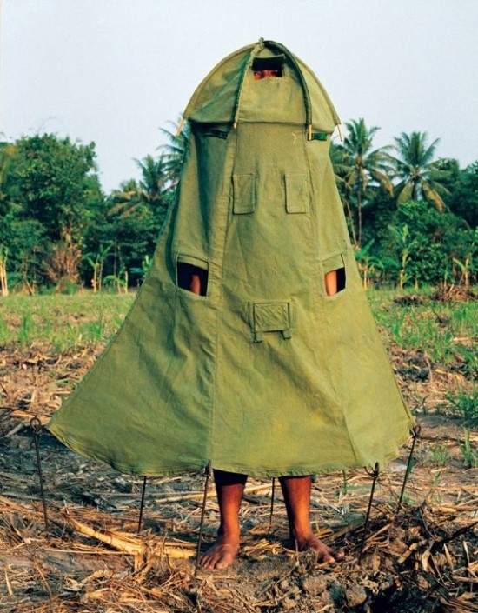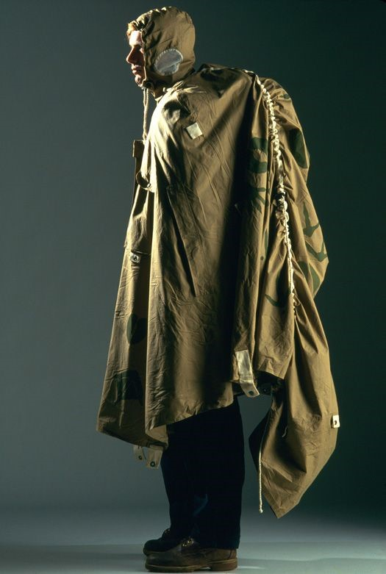

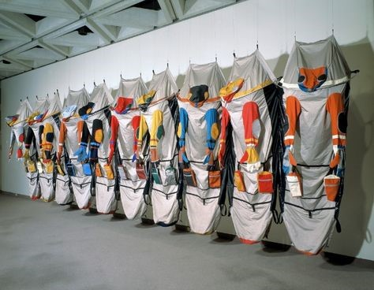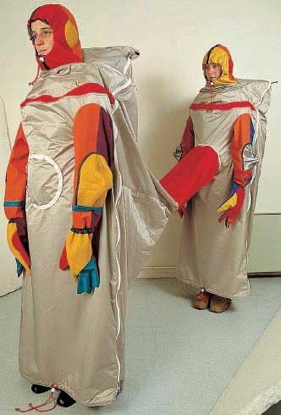
They incorporate the arms and hood appendage, or pockets that contain both functional and symbolic objects.

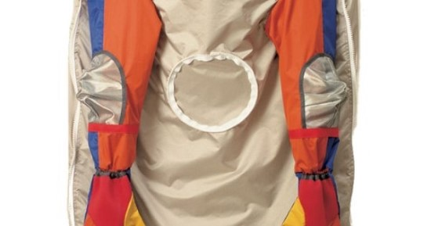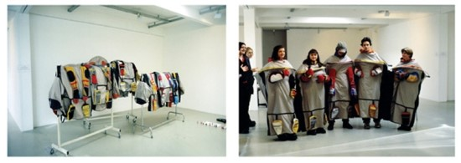

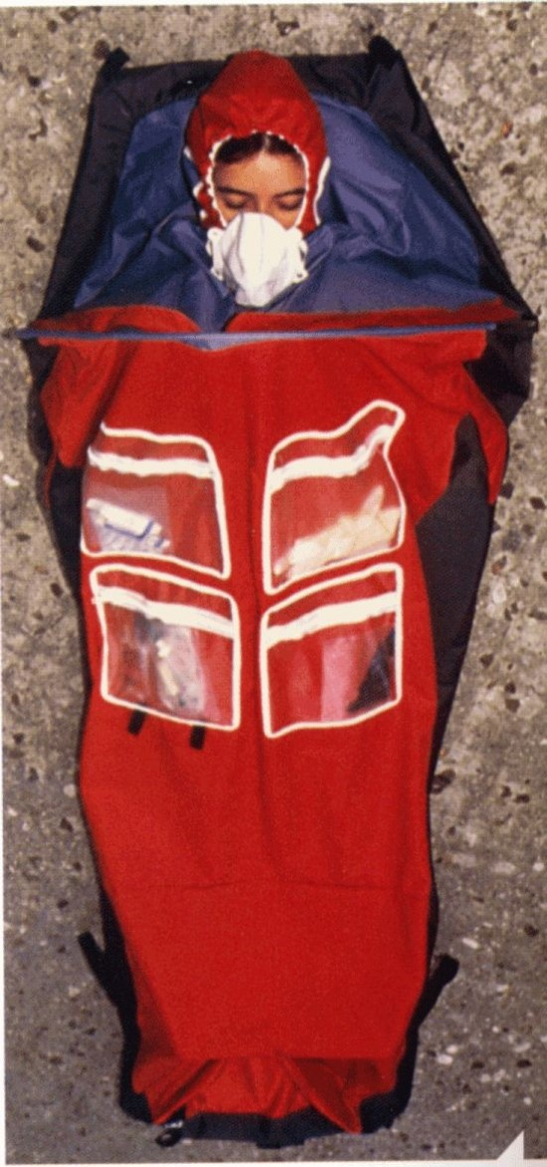

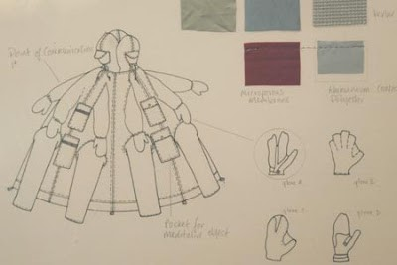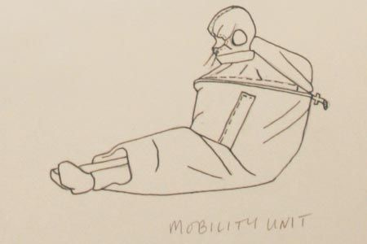
Desgining before making the works.
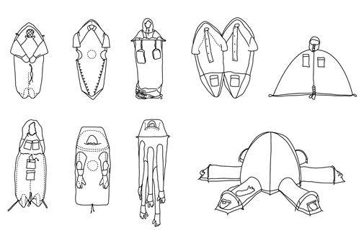

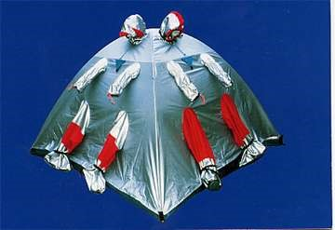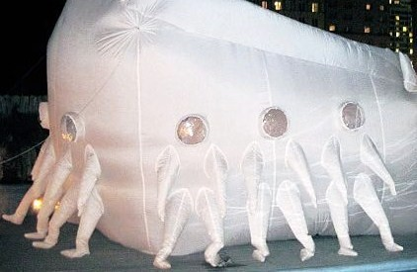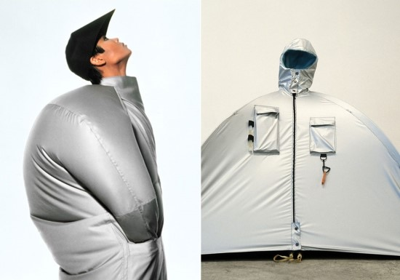

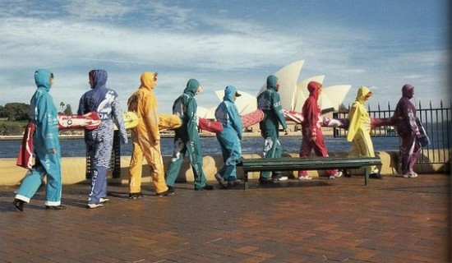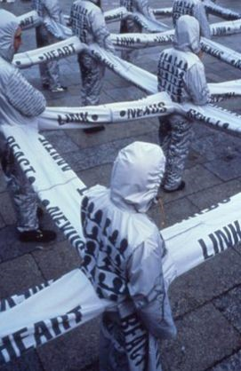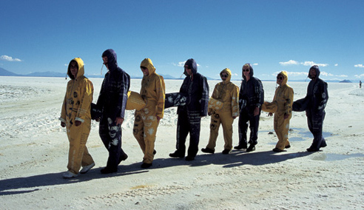

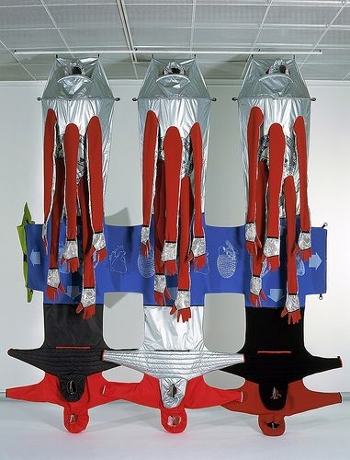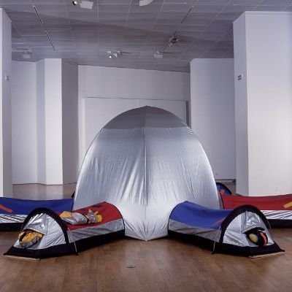

Refugee wear video
Move 'Refugee wear video' block

Lucy Orta: Refuge Wear (1998)

<div class="player-unavailable"><h1 class="message">오류가 발생했습니다.</h1><div class="submessage"><a href="http://www.youtube.com/watch?v=AIwnZFpzzNA" target="_blank">www.youtube.com</a>에서 동영상을 시청하거나 브라우저에서 자바스크립트가 사용 중지된 경우 사용 설정하세요.</div></div>

Richard Mosse-refugee
Move 'Richard Mosse-refugee' block

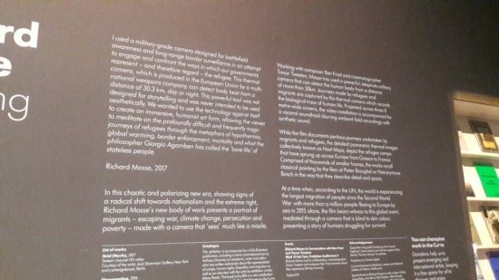
Can you tell me about your new body of work?
*The project charts the refugee crisis unfolding across Europe, the Middle East and North Africa using an extreme telephoto military-grade camera that can detect thermal radiation ? including body heat ? at great distance. I wanted to use this special camera ? which can detect the human body from a distance of 30.3km ? against its intended purpose of border and combat surveillance, to map landscapes of human displacement. Reading heat as both metaphor and index, I wanted to reveal the harsh struggle for survival lived daily by millions of refugees and migrants, while investigating one of the sinister technologies that our governments are using against them. By attaching this camera to a robotic motion-control tripod, I scanned refugee camps across Europe from a high eye-level, to create detailed panoramic thermal images. Each artwork has been painstakingly constructed from a grid of almost a thousand smaller frames, each with its own vanishing point. Seamlessly blended into a single expansive thermal panorama, I was surprised to find that some of the resulting images seem to evoke the spatial description, minute detail, and human narratives of certain kinds of classical painting, such as Breughel or Bosch. Yet they are also documents disclosing the fence architecture, security gates, loudspeakers, food queues, tents and temporary shelters of camp architecture. Very large in scale, these Heat Maps disclose intimate details of fragile human life in squalid, nearly unliveable conditions in the margins and gutters of first world economies.
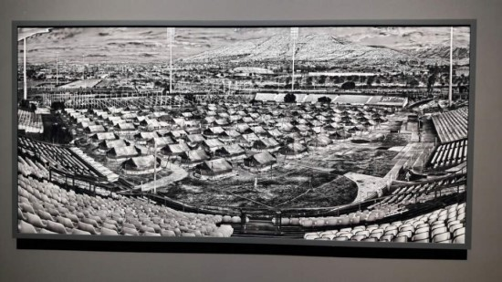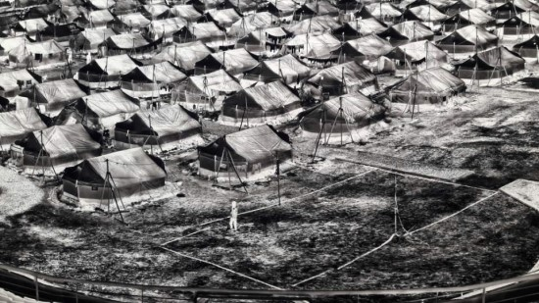

How important is this work for you for recognising the current refugee crisis?
*My approach is clearly not attempting to represent the refugee crisis in a seemingly ?transparent? or objective way ? in the way classic photojournalism does. Instead, it attempts to engage and confront the ways in which we in the west, and our governments, represent ? and therefore regard ? the refugee.
This is a work about the refugee crisis which was made with a border surveillance weapons technology at a moment in history when, for example, Frauke Petry, the chairwoman of the German extreme-right party AfD (Alternative for Germany), has said that police should shoot migrants entering their country illegally.

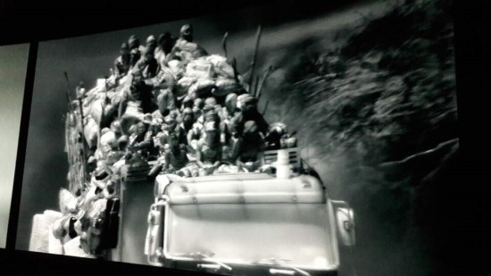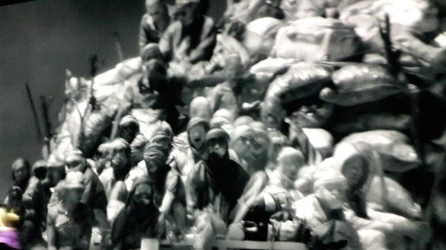

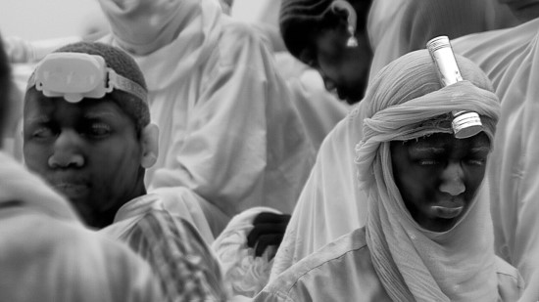

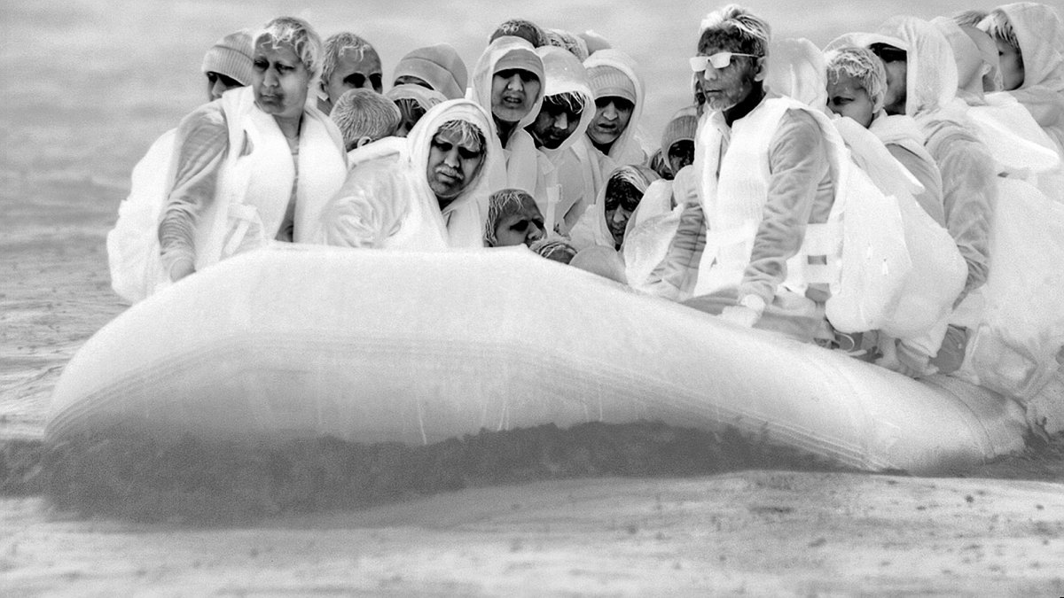

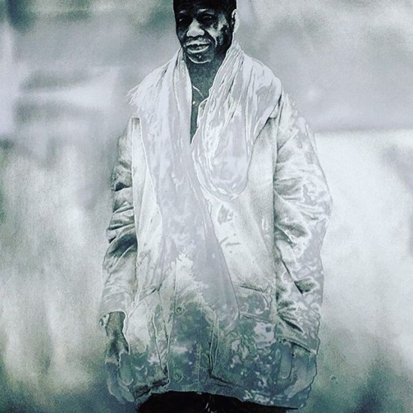

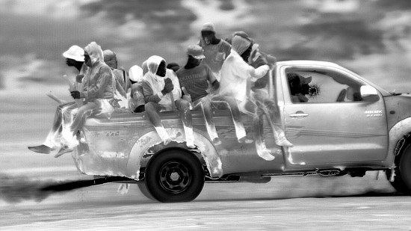

Richard Mosse-refugee video
Move 'Richard Mosse-refugee video' block

KakaoTalk Video 2017 03 13 13 25 28

<div class="player-unavailable"><h1 class="message">오류가 발생했습니다.</h1><div class="submessage"><a href="http://www.youtube.com/watch?v=BJYaDYXru3M" target="_blank">www.youtube.com</a>에서 동영상을 시청하거나 브라우저에서 자바스크립트가 사용 중지된 경우 사용 설정하세요.</div></div>

Text box

*They are living almost like wanderer and nomad. Every night they would have to build temporary camps eventhough they are not builder or worker..They make the temporary house step by step like making frame and put some fabrics like straw up on the frames.
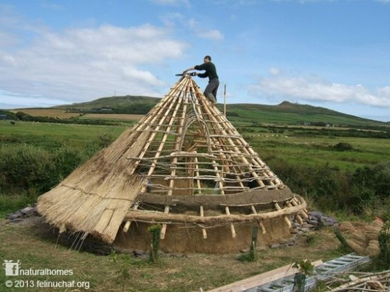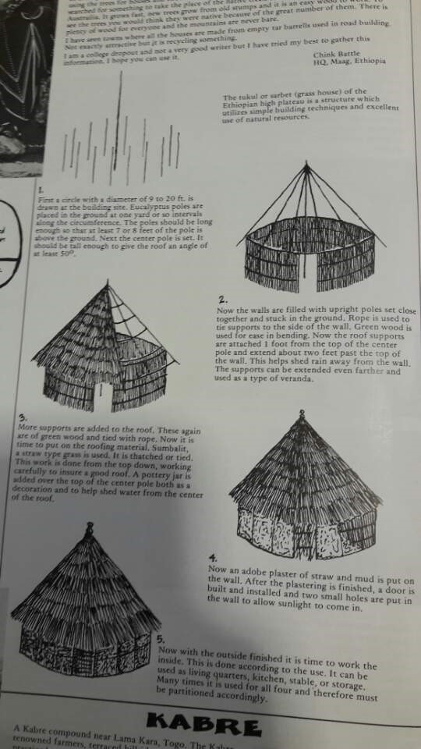

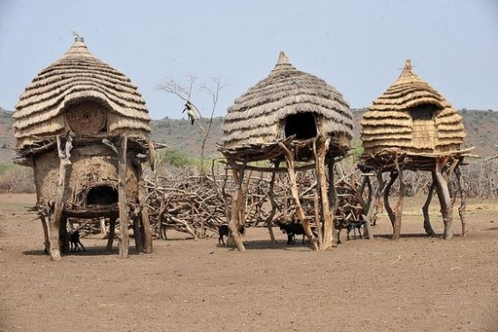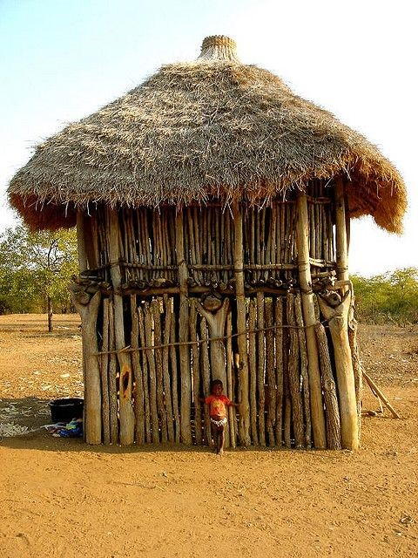

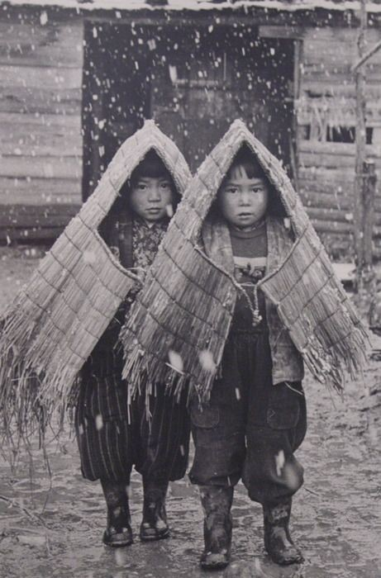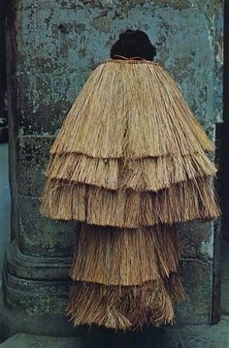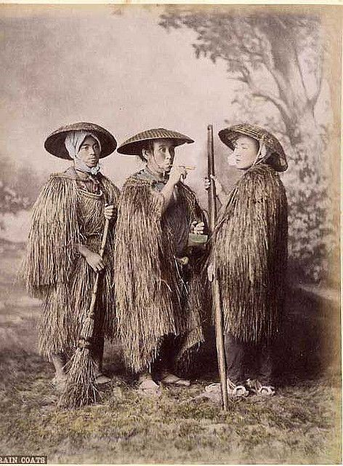
They are covered by straws like the nomadic temporary house

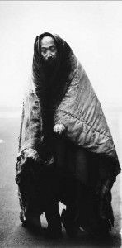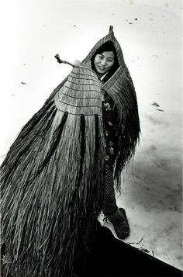

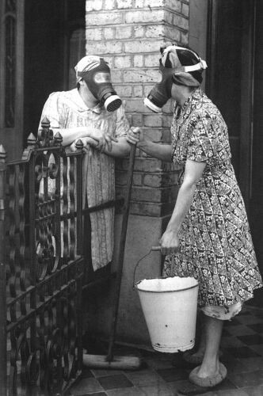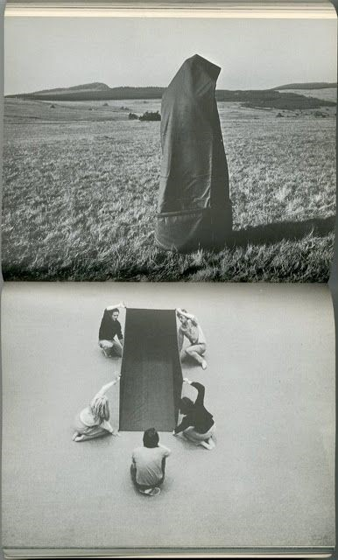

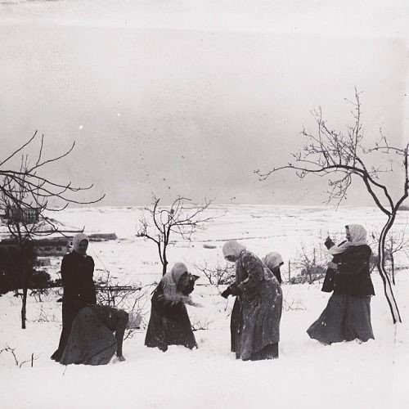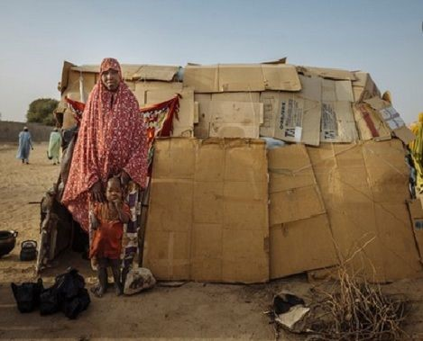

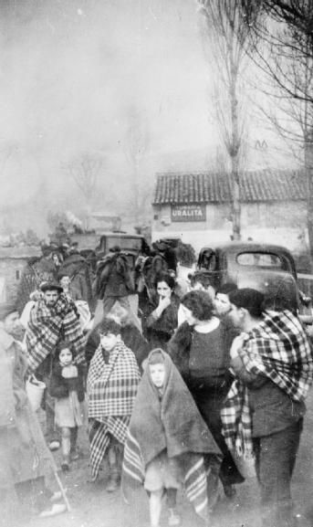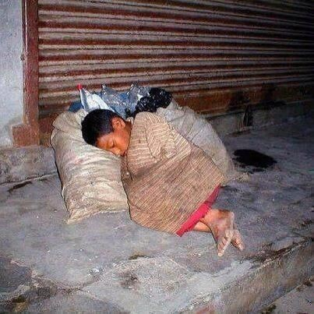

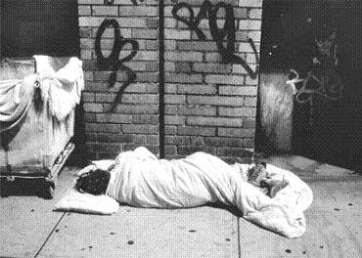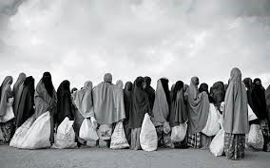
Various impressive temporary shelter for refugee or migrants

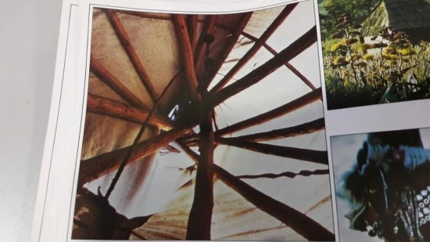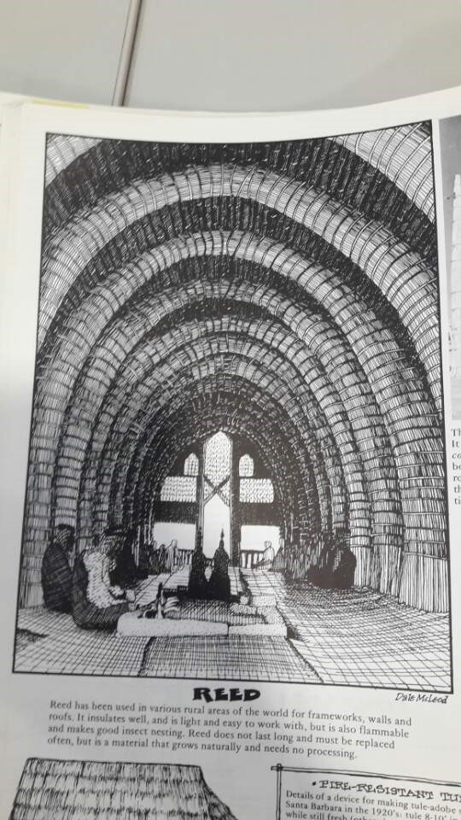

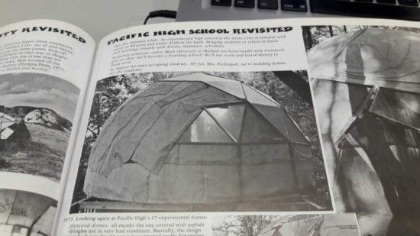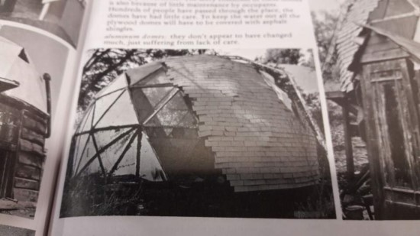

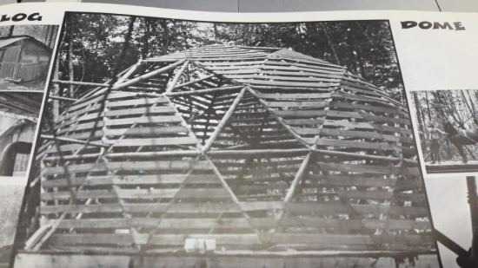

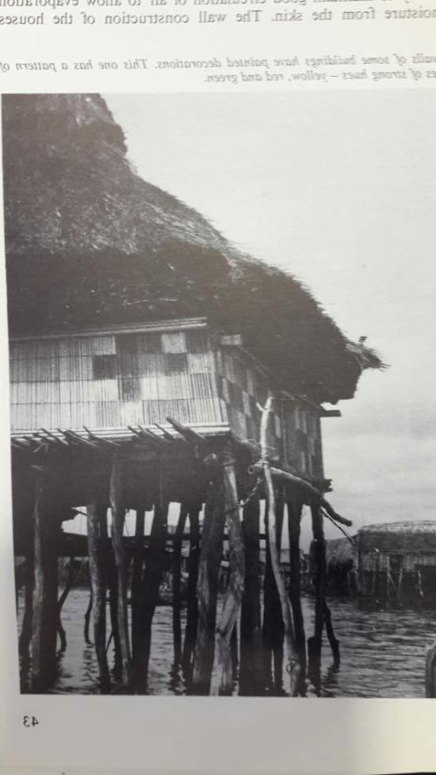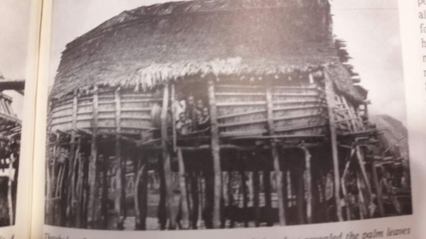

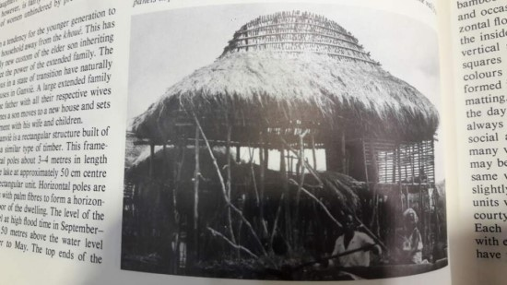

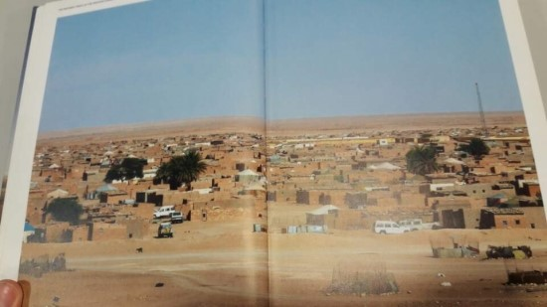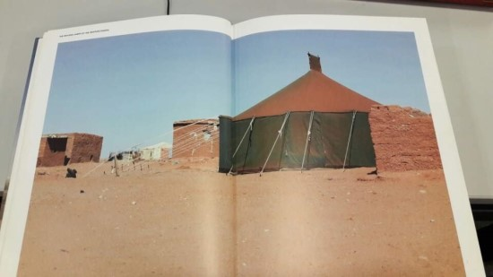

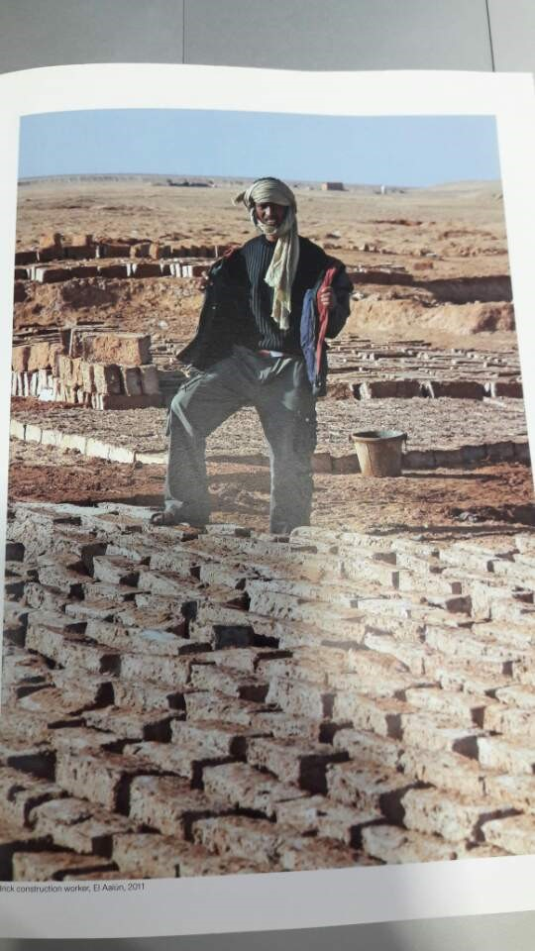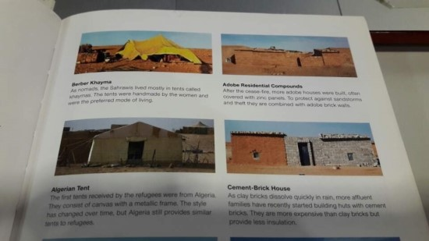

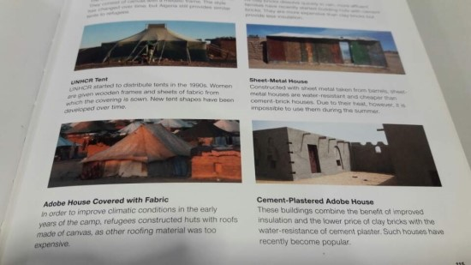

One of the fashion students researched and manipulated very multi functional garments for refugees for their traveling long distances with perfect materials
Move 'One of the fashion students researched and manipulated very multi functional garments for refugees for their traveling long distances with perfect materials' block

Jacket Transforms Into Tent and Sleeping Bag
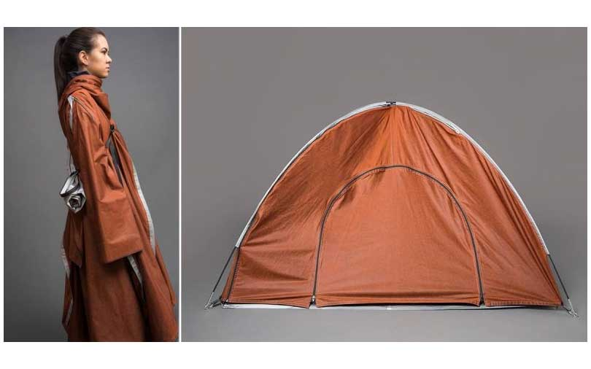

Fashion student, Angela Luna, came up with the idea of blending together fashion design, product design, and addressing social needs and created Adiff. Adiff is a humanitarian fashion startup that cares about social issues and wants to raise awareness while creating innovative products that help people in need.

After doing a lot of research, Angela was first moved by seeing the refugee crisis, and those who had to travel long distances and in different types of conditions. Being a fashion student, she wanted to use her skills to help address a lot of these issues.

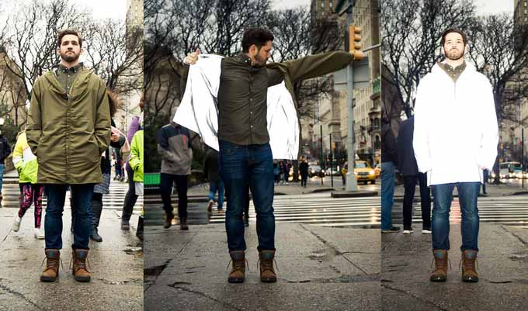
Seeing refugees have to travel by boat, or travel both during the day and at night, being noticeable, but also at times, needing to hide, she began designing transformable clothing that could respond immediately to these needs.

Luna designed lightweight, durable, and waterproof garments that had reflective materials, and other garments that could convert into tents, sleeping bags, and more. The key was to develop clothing that could instantly adapt to different situations and different environments.

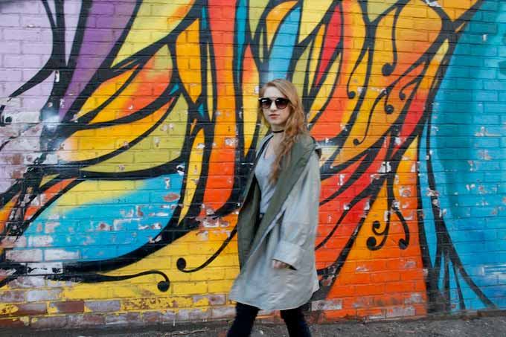

This multi-functional outerwear is ultimately designed to provide shelter, safety, comfort, as well as to raise awareness for the crisis we face today with many people in need, whether it may be the homeless community, or refugees. These garments are currently available for consumer purchase, and for every jacket that is bought, a jacket will be donated to those who need it.

All garments are built to withstand numerous environments, and come in one size, which makes them great for campers, hikers and bikers.

Design for Difference

<div class="player-unavailable"><h1 class="message">오류가 발생했습니다.</h1><div class="submessage"><a href="http://www.youtube.com/watch?v=tlhpQMdONCY" target="_blank">www.youtube.com</a>에서 동영상을 시청하거나 브라우저에서 자바스크립트가 사용 중지된 경우 사용 설정하세요.</div></div>

The Adiff collection includes tent jackets that can be converted into large and small tents fitting up to 5 people. There are also backpack jackets that transform into a cape for added warmth or into a sleeping bag or large blanket.

Angela continues to use fashion to help people and is changing the fashion industry with her work.

http://www.spoutly.com/editors-choice/jacket-transforms-into-tent-and-sleeping-bag/

