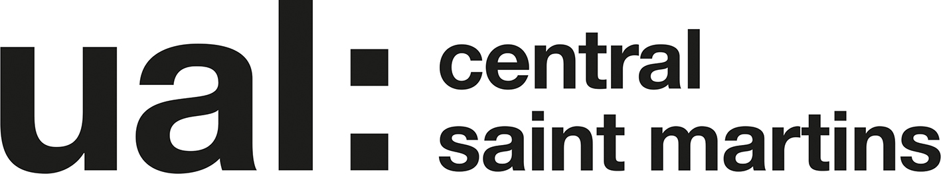

Unit 7 Project Proposal 2018-19 UAL Awarding Body / CSM Foundation

Candidate Name: Eva Dixon Candidate ID Number: 07

Curriculum Area: Fine Art

Pathway: FA: Painting 1, Painting 2, Sculpture, FA: 4D

Delete to leave one pathway

UALAB Unit: Unit 7: Art & Design Project Proposal & Realisation

Project Title: Your title

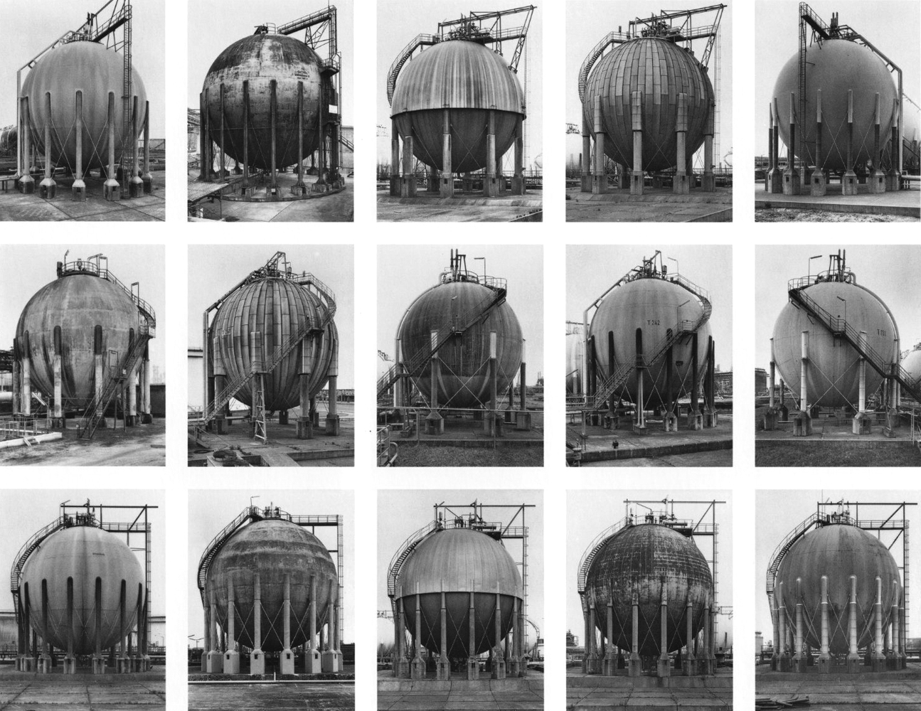

Bernd and Hiller Becher  Gas tanks  1983-92 | Name of artist / influence  Title of work  Date | Name of artist / influence  Title of work  Date

Section 1: Project Review

(Approx. 150 words)
This provides an opportunity for you to reflect on, review and summarise your progress and achievements through the first six units of the program, expressed in terms of the knowledge, skills and understanding acquired. What you now know, and what it means to you, compared with what you knew and could do before you started the course. It also provides an opportunity for you to explain your reasons for choosing a particular pathway and to outline your longer-term aspirations. You should reflect upon how your choice of a particular pathway has informed your project proposal, how it is situated within a broader context and what immediate aspirations will be satisfied through the Project Realisation.
My choice to study painting was primarily informed by my recent history in using oil paint, my works gravitation towards 2D and the artists and work I most connect with were painters. My progression since my specialisation was initially in furthering my knowledge surrounding the origin and production of oil paint along with mediums that vary the qualities of the paint. My knowledge of priming and its effect on surfaces also, along with the order varying paint types can be combined to achieve affects such as cracking. More recently, my work has been more heavily anchored in photography. Initially used as reference images, I have realised that my my work will not necessarily be more effective if I have invested a larger amount of time and more traditional technique into it and that my photos are strong enough on their own and that what I wish to accomplish is mre effectivkey communicated in the directness of film. Time isn’t a measure of quality. This has allowed me to take ownership of my phoots, I have also begun exploring staged phtoograohy through self portraiture to increase the amount of time I invest into shots and exploring whether it strengthens my concept. My understanding of film has become more rounded in terms of 200 400 word and the difference between medium formats. MY relationship[ woth painting has caused me to look at photography through this lens, it also has allowed me to explore the creation of a ‘painting’ from collaged phtoographs and found imagery. Exposign concepts with less technical flare is ffar more testing of my ideas than relying on a technique out of fear a concept is too weak. I have previously associated analog and digital photography/ film woth simplicairy since photoshop is something I was taught in school and pos production I have never had the patience for, only now am I realising that my approach to digital art had been though information studies and is not correct. My research has braodedned dramatically to include a wider bredth of artsiys that fall outdide of the painting spectrum, namelyHannah Starkey and her lonks to subtle feminism, staged photography through era based photos 9WHATS THE WORD FOR OUT OF PLALCE TIME WISE??? Artists such as Hannah Starky have a cincious female suc=bject without pushing fowth the feminist agenda but rather a sade space, the staged photographs appear candid with meticulous detail that could arguably be more effective than candid. My favouoiter of her works are historic/ era based. Micheal Boormans and Daniel Segrove work with founda marterials on which have their own qualtities that become part of the work rather than blank canvas. Segrove doesn’t complete whole drawings in a draditional sense which revelas the process behind the work honestly. The work of Becky Beasley and her inpreretation of photography in a physical sense using 2d surfaces as buikding blocks for the 3d fascinates me even though I fon’t like her work aesthetically. Richard Billigham has a series “Rays a laugh” which has been a huge inspiration for mundane made ambigious. Cinematogeraphy influences my phtography, often my work looks like film stills, this is namely attribute to films such as Carol, Juno the TV series Atypuical and Bewtitched (the colourised version) which is very saturated and timely. I gravitatr towards intimaye angles that depict closeness and relationships bwteen prople.

I want to develop phtoos myself that’s what I want o learn
Becky Beasley
Bill viola

3d realsitation interdisiplnary later on mention w what uou want to do

Section 2: Project Concept & Description

(Approx. 250 words)
This provides an opportunity for you to clearly explain the concept and aims of your project; what you will be researching, what problems are you seeking to resolve, what types of practical methods and skills you are seeking to develop and what technical resources you may need and an indication of the form in which you will present your project realisation.
You should recognise that throughout the project realisation you may, in response to the evolution of your ideas and or the availability of facilities and materials, make decisions, which result in changes to the project concept and aims. It is important that any process of change is documented in both the work itself and through supporting records, e.g. a personal reflective journal.
I am interested in my sexuality, history and relationship past in contributing to my desire for intimacy. My neurological response to intimacy, its calming nature which I attribute to sleeping (considering I have insomnia and ADHD). My gravitation towards calming hand movements and ASMR in bringing artificial intimacy. In a physical sense this is visualised in bedrooms. I would like to investigate the effects of trauma delivery in bedrooms, namely news about major relocations as a child and the death of my best friend and partner. The underlying sexual nature of beds directly translates to romantic intimacy I have not desired but allowed to happen in conjunction with the guilt and suppression I associate with suggesting my previous romantic relationships were less valid, despite my platonic emotions. My insomnia is less pronounced in the company of another person or when lying in the open in locations like parks. I wish to investigate intimacy in others (and my own through replication) to determine whether it is possible to shed light on accepting my identity. In turn replicating relaxation style videos in a more visual than auditory sense, with emphasis on touch as I have a compulsive desire to document day to day life out of fear for loss, however, what always keeps distance is touch. Through film photography, projection and found imagery and collage I would like to construct a series of works that explore touch as an intangible component of death and more conceptually my desire for intimacy brought about by my sexuality. I will take inspirartion from cinematic stills and their narrative, literature (Michelangelo and his debate of platonic and spiritual loe in regard to his lover) personal experience (including the reconstruction (staging) of memorable strands of emotion within my parents bedroom). Contradiction to love a boy but want girls ever since he died but know its always been the truth. I intent to research the work of Bill Viola more intensly along with the effect of the outdoors on health, the replication and understanding of artificial/ stimulated intimacy, time, Hannah Starkey’s staged photography and Becky Beasley (her exhibition on rooms and the architect who inspired her and didn’t live in the apartment). I would like to communicate extreme intimacy to the point of discomfort. I will draw inspiration from the 1960’s domestic life and living spaces (as exposed by my grandmother) and the associated heavy saturated images I wish to create.

Section 3: Project Evaluation

(Approx. 100 words)
This provides an opportunity for you to explain the means by which you will reflect on, and evaluate, your work, as both a continuous activity and in summation at the conclusion of the project. The critical review should be referenced to the projects stated aims and be reflective and analytical of learning and achievement rather than a narrative of actions completed.

I will evaluate the effectiveness of my project through peer feedback, tutorials and critiques. I will also chart my progress alongside my planning calendar, the direction of my work in relation to my starting point on Workflow to measure the amount of growth or redirection of my ideas and the feeling of a separation between my past and present body of work, fully accepting ownership of my creations. The breadth of my experimentation and outcomes will allow me to understand my growth. The more relevant sites I have visited the more wide spanning my inspirations will be and the stronger my work for it.

Section 4: Proposed Research Resources and Bibliography

Bibliography (Harvard Format): provides an opportunity to formally record the research sources that you have used. You should record your initial research sources for the project proposal and then continuously update the bibliography as the project progresses. (See separate notes)

Section 5: Project Action Plan and Timetable:

To help you achieve your goals a provisional action plan/timetable must be attached.
Your action plan should include what you are going to do, how you will do it and by when. The more time and thought you give to the planning of your project the more successful it is likely to be. Remember to consider time taken in visiting research sources, sourcing materials, questionnaires, access to workshops and tutorial opportunities.

https://www-ingentaconnect-com.arts.idm.oclc.org/content/wk/bepha/2016/00000027/00000008/art00007

https://onlinelibrary-wiley-com.arts.idm.oclc.org/doi/10.1002/ajmg.b.32343

- http://time.com/5379586/people-hate-hugged-science/
- https://www.youtube.com/watch?v=DxjfyBEIl7Q

- https://info.dralexrinehart.com/articles/stress-benefits/how-to-increase-oxytocin

- https://learningonscreen.ac.uk/ondemand/index.php/prog/0803BCAE?bcast=114515733

- https://www.youtube.com/watch?v=Mqaobr6w6_I

- https://www.syfy.com/syfywire/bewitched-and-the-evolution-of-60s-gender-norms

- https://www.youtube.com/watch?v=f5qp3vAVX9s

- https://www.youtube.com/watch?v=-BXvhfm2Jac

- https://www.tate.org.uk/whats-on/tate-britain/display/art-now-becky-beasley-outside/art-now-becky-beasley-essay-outside

- http://moussemagazine.it/becky-beasley-the-outside-at-francesca-minini-milan/

- https://www.independent.co.uk/news/people/profiles/richard-billingham-its-all-in-the-eye-of-the-beholder-9273785.html
- https://www.youtube.com/watch?v=GK7wOgORDYk

- https://www.youtube.com/watch?v=WQCx6AS53Wc

Week | Date week  begins | Activity / What you are intending to do - including independent study | Resources / What you will need to do it - including access to workshops
Week 23 | Feb  18th | Independent Research Week, online research, reflection  18th: research day, Tracy Emin White cube, online research, reflection, sketchbook work  19th: Slade interview, Kew Gardens, sketchbook work, reflection and online research  20th: Brighton: queer history, reflection and sketchbook work  21st: butterfly sanctuary (The Broad Walk), book in visit to the art deco building in crouch end  22nd: Imperial war museum, documentary and movie day, staged photography  21st:  READING LIST:  - touch  - different for girls  - queer history
Week 24 | Feb  25th
Week 25 | March 4th
Week 26 | March 11th | Progress Tutorials in 202
Week 27 | March 18th
Week 28 | March 25th | Group review of progress  Peer assessment of supporting work  Tuesday 26th: All contextual texts for Park handed in via Moodle. Work should be completed for Park
Easter Break  Week  1 | April 1st |  | Workshops closed
Easter Break  Week  2 | April 8th |  | Workshops closed
Week 29 | April  15th | Tuesday April 16th:  Deadline for submissions for King’s Cross  Final check of work for Sculpture trail  Deadline for submission of video for LUX
Week 30 | April  22nd | Pack and install work for Park
Week 31 | April 29th | Make studio ready for assessment  Peer assessment of completed works
Week 32 | May 6th | May 7th 2pm; Deadline for submission of Unit 7 work

Thursday 14th Feb
Project Proposal First Draft.
(At least sections 1, 2 and 3 completed).
Printed as hard copy and brought in to class.

Thursday 28th Feb
Project Proposal Final document.
(Sections 1, 2 and 3, improved after draft + section 4 and 5).
Uploaded as an electronic copy in a folder called ‘PPP’ in your Part 3 Workflow area. Save the proposal using the naming format in the title of this document.

Learning Outcomes for Unit 7

Ask yourself these questions to ensure that your proposed project work will meet the assessment criteria.

What are the critical and contextual perspectives of your proposed project?

How will you research, analyse and evaluate your ideas to help develop creative solutions?

How will you solve complex problems through practical, theoretical and technical understanding?

How will you adapt and use appropriate practical methods and skills for creative production?

How will you use evaluative and reflective skills in order to take responsibility for your own learning, development and effective decision-making?

How will you critically review the effectiveness and appropriateness of your planning, methods, actions and results?

How will you effectively present yourself and your work to appropriate audiences?

