Unit 7 Project - Project Proposal 2017/18 UAL Awarding Body / CSM Foundation

Candidate Name: Nayiri Gharibian Saki Candidate ID Number: GHA17513541

Curriculum Area: Fashion & Textiles

Pathway: Textiles

UALAB Unit: Unit 7 - Art & Design Project Proposal & Realisation

Project Title: Theme of Self Identity

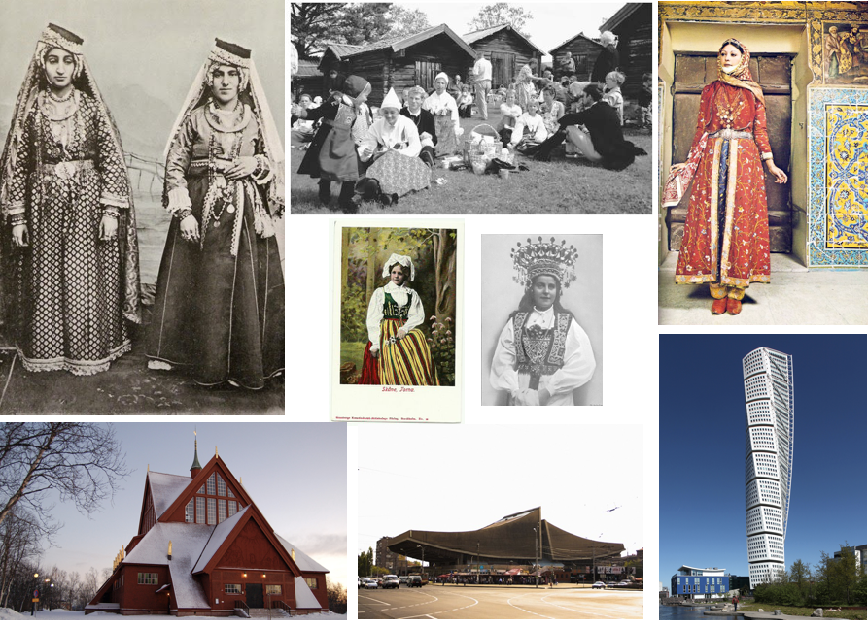
Project Review

Throughout the first initial six units, I have grown as a fashion and textile student. Being acquainted with new skills such as weaving, knitting and lino prints has allowed me to create more dynamic final outcomes as well as push me as an art student to be more experimental. Whilst in diagnostic I was unsure if I wanted to specialize in Fashion or textiles, by choosing textiles not only have I become more aware of forms and ways in which clothing can manipulate the body, however as well as considering materials I can use. Textiles has pushed me to question the reason for my chosen materials, as well as considering creating my own samples instead of found ones. This has allowed my work to become more dynamic and ultimately more interesting. My longer-term aspirations related to unit 7 are that I am willing to learn more intricate techniques related to knitting and weaving as well as being open minded to experimentation of colour and print.

Project Concept & Description

Being Swedish and Armenian, my identity as a person has been quite of a mixture. Both countries present traditions and history that do not correlate, but also their present state is highly different.
The functional Scandinavian highly developed way of life is no comparison to Armenia’s newly emerging government and lifestyle that endured the Soviet turmoil. A now developing country, the sheer contrast between the lives both populations live is so drastic. This places me as a citizen of both in an interesting spot, where I live both aspects of an Armenian as well as Swedish life. What I want to convey within this project is the internal juxtaposition that I myself as a person have endured, but shaped me as the person I am now.

The aim of the project will be to integrate both aspects of my Armenian roots, therefore exploring weaving and tapestry in warm rich earth tones, a traditional craft that is highly respected in the region Armenia lies in. Moreover, I will be mixing the ideas of Scandinavian design, therefore simplicity and minimalism. To do so, I will be focusing mainly on creating textures on fabrics with minimal colour use. By exploring the architectural shapes and forms of Swedish architecture as well as post Soviet era buildings scattered throughout Armenia, I want to capture the prevalent differences within Armenian and Swedish aesthetics. I want the spectator to see a final outcome that explores this contradiction of my identity but still presents a harmony and a conformity that has built me as an individual through a garment, therefore translating my internal identity externally to visually be able to see.

Project Evaluation

Throughout the project I will be exploring this stated contrast between my two cultures. To do so, I will create a multitude of samples where I explore, colour shape and form. Moreover, as my idea is to create a desired contrast I will have to still create a harmony between the samples which I create to metaphorically express how both my Armenian roots and Swedish roots merge together.

Throughout the project, it is vital that I do not only look at Armenian and Swedish craftsmanship, but ways in which other artists such as El Anatsui express similar ideas of weaving and tapestries to express their own identity – therefore it will be vital to understand ways in which other artists/designers achieve similar themes to the one I try and project. With the aim of intertwining traditional Armenian patterns and Scandinavian ones, it will be important to express them with colour as well as important craftsmanship such as embroidery that both cultures have. However, these patterns will be questioned and altered in conjunction to architectural elements, to create a dynamic final outcome.

Proposed Research Resources and Bibliography

“Kütahya Cermanics And International Armenian Trade Networks – Victoria and Albert Museum.” Vam.ac.uk. N.p., 2018. Web. 1 Mar. 2018.
“Meet The Guy With The World’S Largest Collection Of Soviet Bus Stop Photos.” Vice. N.p., 2018. Web. 1 Mar. 2018.

“Minas Avetisyan – Armenian Gallery.” Armenia Gallery. N.p. , 2018
Åhrén, Uno et al. Modern Swedish Design. New York: The Museum of Modern Art, 2008. Print.

Binder, Lisa M. El Anatsui. Long Island City, NY: Museum for African Art, 2010. Print.

Ft.com. (2018). Cultural identity: fabric in African art. [online] Available at: https://www.ft.com/content/97c85384-fa80-11e6-bd4e-68d53499ed71 [Accessed 10 March. 2018].

Gumpert, Lynn et al. The Poetics Of Cloth. New York, NY: Grey Art Gallery, 2008. Print.

Gumpert, Lynn, and Shiva Balaghi. Picturing Iran. London: I.B. Tauris, 2003. Print.
Herwig, Christopher. Soviet Bus Stops. London: Fuel, 2016. Print.

Khan Magomedov, Selim Omarovic, and Alexander Lieven. Pioneers Of Soviet Architecture. London: Thames and Hudson, 1987. Print.

Mattsson, Helena, and Sven-Olov Wallenstein. Swedish Modernism. London: Black Dog, 2010. Print.

Murphy, Keith M. Swedish Design: An Ethnography. Cornell University Press, 2015. Print.

Ryabushin, Alexander, and Nadia Smolina. Landmarks Of Soviet Architecture 1917-1991. Berlin: Ernst & Sohn, 1992. Print.

Sculpture Nature. (2017). Material matters: El Anatsui – Sculpture Nature. [online] Available at: http://www.sculpturenature.com/en/material-matters-el-anatsui/ [Accessed 13 March. 2018].

Sil.si.edu. (2018). [online] Available at: http://www.sil.si.edu/DigitalCollections/locally_hosted/Exploring_Identity_Art_of_El_Anatsui_and_Kwesi_Owusu_Ankomah.pdf [Accessed 10 March. 2018].

Vardanyan, Tatevik. “The Unbearable Grayness Of Buildings: Soviet Architecture In Armenia [Photo] – The Armenite.” The Armenite. N,p., 2018. Web.11 Mar. 2018.

Project Action Plan and Timetable:

Week | Date Week  beginning | Activity / What you are intending to do - including independent study | Resources / What you will need to do it - including access to workshops
Week 23 | Feb  19th | Independent Research Week | Visit V&A, look at traditional tapestries as well as small collection of Armenian plates with traditional blue patterns. – Possible research for prints to do on printing press (workshop)  Fabric research for both Scandinavian and Armenian samples.  Research in Armenian weaving and tapestries as well as Scandinavian authentic colour palettes.  Explore folk clothing; look at shapes as well as common silhouettes.  Scandinavian architecture and its contrast to Armenian tapestries – colour contrasts + shapes.  Create samples in workshop on weaving looms as well as exploration of fabric manipulation + knitting.  CSM library visit, looking at evolution of clothing within both regions + information about craftsmanship  Further research on other artists such as Minas Avetisyan and Martiros Saryan, two Armenian fine artists and ways in which they express Armenian tradition and heritage.
Week 24 | Feb  26th | Final Proposal Hand in Deadline | Finalise proposal  Read interviews about artists that express their identity – their motives, what they try and present within their artwork and how they convey it through a final outcome. (Ways in which their traditional crafts are explored and metaphorically express their identity – El Anatsui’s tapestries).  Start looking at crochet and ways in which they can be incorporated in final garment.
Week 25 | March 5th | Introduction of the Live Project | Research in correlation to Harrods Green Man: Look at Harrods Green Women and how women’s roles quickly changed during World War One.  Research of Flappers, ways in which they questioned female identity within society in the Roaring 20’s.  Visit V&A and their Art Deco archive, to understand the aesthetics of the 20’s as well as correlation to societal and female attitudes.
Week 26 | March 12th | Progress Tutorials, Initial selection Crit of Live Project. | Receive feedback from progress Tutorial. Finalise what direction Harrods Live Project will take (what I want to convey through a final garment in relation to research done above)  +  As well as considering merging of Swedish and Armenian architectural forms and patterns.
Week 27 | March 19th |  | Unit 7 Self Identity Project : start considering forms on the body as well as using the Heat Press to create small patterns inspired by Armenian Kütahya  and Swedish Dala design.  Harrods Project: Start translating ideas of female empowerment considered in the 20’s in retrospective to the Harrods Green Man uniform – showing how women through 1915 to 1918 upheld Harrods identity of Green Men. Somehow giving homage to the women that where later sacked from their jobs.
Easter Break  Week  1 | March 26th |  | Workshops closed  Art Gallery Visits
Easter Break  Week  2 | April  2nd |  | Workshops closed
Week 28 | April  9th |  | Expand knowledge on crochet and experiment with details for Unit 7 – Self Identity project.  Start thinking of a final garment though the experimentation and sketches done prior.
Week 29 | April  16th | DEADLINE for Unit 7 Assessment submission is Tuesday 17th April, 4.00pm | . /

