`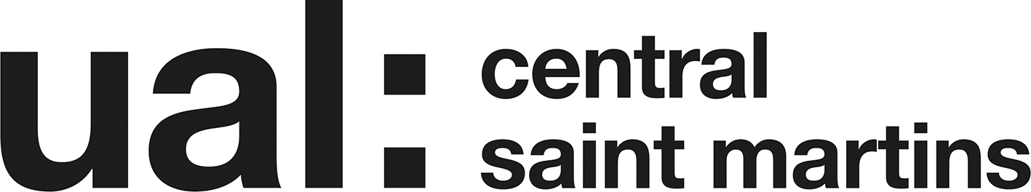

Unit 7 Project Project Proposal 2016/17 UAL Awarding Body / CSM Foundation

Candidate Name: Dongyeon(randy) Kim Candidate ID Number: KIM16487775

Curriculum Area: Fashion & Textiles

Pathway: Fashion - Textiles

UALAB Unit: Unit 7 - Art & Design Project Proposal & Realisation

Project Title: Restriction: Surrounding-shelter

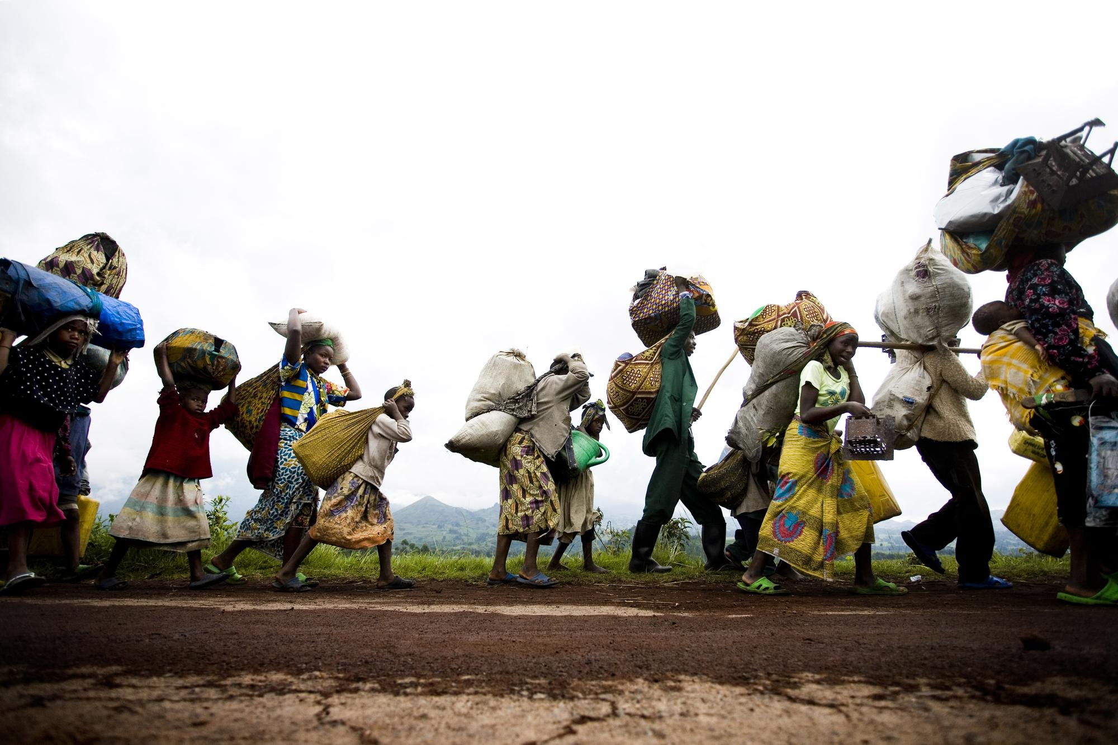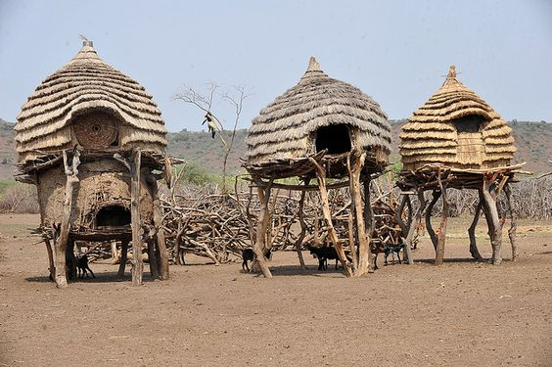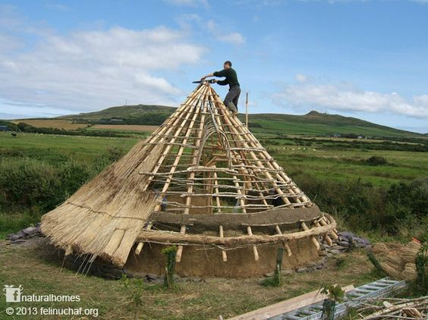

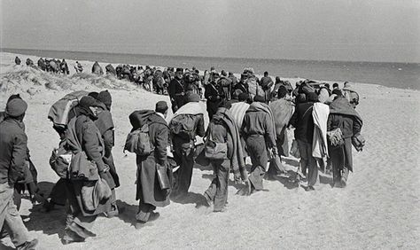

Project Review

To be fair, I didn’t learn a lot of skills through part1 and 2 of the course but I learned and made progress in a few big things. First off, I think I developed self-study skill a lot. Because I got private lessons how to make portfolio before I came here, they taught me various ways to study fashion. In this foundation course tutors respected my concept and developing process even though what I did were not that good and they told me another way of developing which I have never thought. They didn’t touch my work too much but informed me different ways to improve the quality of process and helped me to break conventional thinking and to think outside the box. I was not that familiar to using diverse colours but they required us to use many different drawing materials and colours so I also learned using colours well.

Project Concept & Description

This is my own learning project. I am asked to research significant events after choosing a specific theme among some given themes like surrounding, security and self. I began my research by using the library at CSM, internet and exhibitions. I chose my concept as shelter from surroundings theme as the research I was able to get off of It was intriguing. I was quite impressed by the reality of refugee especially their life which inspired me a lot. They live a difficult life in different locations, moving one place to another with a lot of burdens to escape from war or persecution. Even though it isn’t any of their fault they are almost forced to flee their home and there are not many countries to welcome and accept them. I think they are the biggest victim of wars. I will be researching about their life. The problems I’m seeking to resolve is how to develop my collection with body and how to drape and do 3Dworks to be related to final idea. The problems I have had until now is creating garments that are too focused on functionality and wear-ability. I want to be able combine both elements of functionality and abstractness to create more innovative designs. There are good sides to this but I want to show that I can design abstractive and portray artistic skill through final line up in this project. I also want to develop collaging skills as well as draping techniques to make it easier to portray my ideas and points.
----------------------------------------------------------------------------------------------------------------------
Outcome: Final line up

Project Evaluation

As I mentioned above, my theme is shelter and I chose the concept as Refugee. I will find some interesting images and their life story. They are living almost like wanderer and nomad. Every night they would have to build temporary camps. Even though it’s not their fault, each choice can be a matter of life or death. The biggest problem is that there are many countries that do not welcome them. The overall aim of my project is showing the refugees’ hard life to them and winning them over to think again about accepting refugees.

Proposed Research Resources and Bibliography

Barrie & Jenkins (1976 )Shelter and society: New Studies in Vernacular Architecture.
Ten Speed Press, Bolinas, California, U.S.A (1990) Shelter
Meador, Clifton (2005) Tourist refugee

Project Action Plan and Timetable:

Week | Date Week  beginning | Activity / What you are intending to do - including independent study | Resources / What you will need to do it - including access to workshops
Week 23 | Feb  20th | Independent Research Week | Using library, Going gallery
Week 24 | Feb  27th | Draft proposal hand in, Presentation of visuals reflecting individual themes and research. Self-directed study. Finding out what is lack.
Week 25 | March 6th | Collaging with unusual fabrics and doing 3D works like manipulating 3D structure or patterns by using paper or unique fabric
Week 26 | March 13th | Progress Tutorials
Week 27 | March 20th | Modifying the previous works and think again about next step of developing.
Easter Break  Week  1 | March 27th | Visiting various museum and gallery to inspire me about my concept and on my development process. | Workshops closed
Easter Break  Week  2 | April  3rd | Visiting various museum and gallery to inspire me about my concept and on my development process. And doing 3D works based on the idea | Workshops closed
Week 28 | April  10th | Drawing designs a lot of times and choose the designs which are the best and drawing and thinking about details and making them
Week 29 | April  17th | Manipulating 3Dworkes  with final idea
Week 30 | April  24th | Setting up the Exhibition on Mon 24th and Tue 25th  DEADLINE for Unit 7 Assessment submission is Tuesday 25th April, 4.00pm

